August-November 2024
CS616: Statistical Pattern Recognition
CS612: Statistical Pattern Recognition Laboratory
Programming Assignment 4 Report

Submitted by Group 03

Pawan Ram Mali (PhD) | Abhishek Sharma (MS) | Sachin Maurya (MS)
Department of CSE  Indian Institute of Technology | Department of CSE  Indian Institute of Technology | Department of CSE  Indian Institute of Technology
Dharwad, India | Dharwad, India | Dharwad, India
cs24dp011@iitdh.ac.in | cs24ms003@iitdh.ac.in | cs24ms002@iitdh.ac.in

Contents
I. Introduction 5
A. Overview of the Assignment and Objectives 5
B. Datasets Description 5
Dataset 1: 2-dimensional artificial data 5
Dataset 2: 3-class scene image dataset 5
II. Dataset 1: 2-Dimensional Artificial Data 6
A. Methodology 6
1. Bayes Classifier Using KNN Density Estimation 6
2. Fisher Linear Discriminant Analysis (FDA) 6
3. Perceptron-Based Classifier 6
4. Logistic Regression Classifier 6
5. SVM-Based Classifier 6
B. Results and Analysis 7
1. Classifier Performance Metrics 28
2. KNN-Based Bayes Classifier Analysis 45
3. FDA Analysis 45
4. Perceptron Analysis 46
5. Logistic Regression Analysis 46
6. SVM Analysis 46
C. Comparative Analysis 46
1. Decision Region Plots 46
2. Special Comparisons 46
III. Dataset 2: 3-Class Scene Image Dataset 47
A. Methodology 47
1. Bayes Classifier Using GMM 47
2. Bayes Classifier Using KNN 47
3. FDA Implementation 47
4. Perceptron Implementation 47
5. Logistic Regression Implementation 47
6. SVM Implementation 47
B. Results and Analysis 48
1. Classifier Performance Metrics Error! Bookmark not defined.
2. GMM Analysis Error! Bookmark not defined.
3. KNN Analysis Error! Bookmark not defined.
4. FDA Performance Error! Bookmark not defined.
5. Perceptron and Logistic Regression Results Error! Bookmark not defined.
6. SVM Results Error! Bookmark not defined.
C. Dimensionality Reduction Analysis 71
1. PCA Analysis 71
2. FDA Analysis 71
IV. Overall Comparative Analysis 72
A. Cross-Assignment Comparison 72
V. Conclusion 73
A. Key Findings 73
B. Best Performing Methods 73
C. Analysis Insights 73
VI. References 74

List of Figures

Figure 1 GMM based Classifier Decision Regions for different number of components 7
Figure 2 GMM Cluster centers for different GMM components 8
Figure 3 KNN Decision Regions 9
Figure 4 Original Space & Projected Space in FDA 10
Figure 5 Perceptron Decision Regions 11
Figure 6 Logistic Regression Decision Regions 11
Figure 7 SVM Decision Regions 12
Figure 8 SVM Decision Regions 13
Figure 9 GMM Based Classifier Decision Regions for Components 1 to 8 15
Figure 10 GMM Based Classifier Decision Regions for Components 16 16
Figure 11 GMM Cluster centers for GMM Components 1 to 2 17
Figure 12 GMM Cluster centers for GMM Components 4 to 8 18
Figure 13 GMM Cluster centers for GMM Components 16 19
Figure 14 FDA 1D Projection 19
Figure 15 Perceptron Decision Boundary 20
Figure 16 Logistic Regression Decision Boundary 20
Figure 17 SVM Linear Decision Boundary 21
Figure 18 SVM Polynomial Decision Boundary for Degree = 2 22
Figure 19 SVM Polynomial Decision Boundary for Degree = 3 23
Figure 20 SVM Polynomial Decision Boundary for Degree = 4 24
Figure 21 SVM RBF Decision Boundary (gamma =0.01) 25
Figure 22 SVM RBF Decision Boundary (gamma =0.1) 26
Figure 23 SVM RBF Decision Boundary (gamma =1) 27
Figure 24 Variation of Eigenvalues 48

I. Introduction

A. Overview of the Assignment and Objectives
This assignment aims to apply statistical pattern recognition techniques to two datasets: a 2D artificial dataset and a 3-class scene image dataset. The primary objectives are:
- Implementation of classifiers, including Bayes classifier, KNN-based density estimation, FDA, perceptron, logistic regression, and SVM with various kernels.
- Evaluation of classifier performance using metrics such as accuracy, precision, recall, and F-measure.
- Visualization and analysis of decision boundaries, dimensionality reduction techniques, and cross-method comparisons.

B. Datasets Description

Dataset 1: 2-dimensional artificial data
  - Contains two subsets:
    - Linearly separable dataset: Suitable for evaluating classifiers with linear decision boundaries.
    - Nonlinearly separable dataset: Tests classifiers' abilities to handle non-linear relationships.

Dataset 2: 3-class scene image dataset
  - Represented as 32-dimensional Bag-of-Visual-Words (BoVW) features derived from images.
  - Requires dimensionality reduction (e.g., PCA) to manage high dimensionality.

II. Dataset 1: 2-Dimensional Artificial Data

A. Methodology

1. Bayes Classifier Using KNN Density Estimation
- Experimented with different KKK values (e.g., K=1,3,5,7K=1, 3, 5, 7K=1,3,5,7).
- Implementation details:
  - Density estimation was performed using KNN for both datasets.
  - Decision boundaries were visualized to analyze the impact of KKK on classification performance.

2. Fisher Linear Discriminant Analysis (FDA)
- Implemented FDA to reduce data dimensionality and trained Bayes classifiers:
  - Using unimodal Gaussian densities.
  - Using GMMs with varying numbers of mixtures.

3. Perceptron-Based Classifier
- Implementation:
  - Trained perceptron using a standard update rule on linearly and nonlinearly separable datasets.
- Training focused on convergence and robustness against non-linearity.

4. Logistic Regression Classifier
- Applied a gradient-descent approach to optimize parameters.
- Regularization techniques were explored to prevent overfitting.

5. SVM-Based Classifier
- Implemented SVM using:
  - Linear kernel.
  - Polynomial kernel with varying degrees.
  - Gaussian/RBF kernel with different bandwidth parameters.
- Parameters were tuned to optimize performance for both linear and non-linear datasets.

B. Plot Visualizations for Linearly Separable Dataset

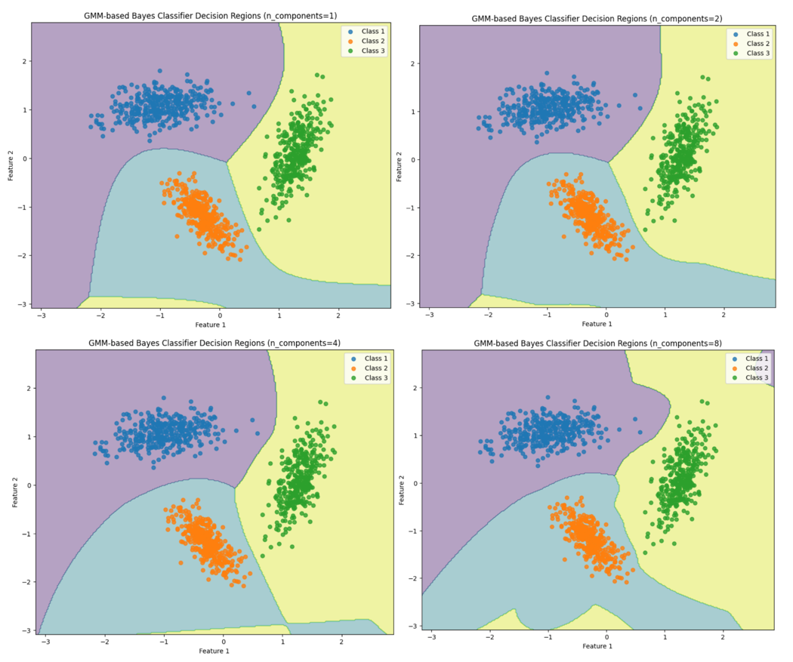
Figure 1 GMM based Classifier Decision Regions for different number of components

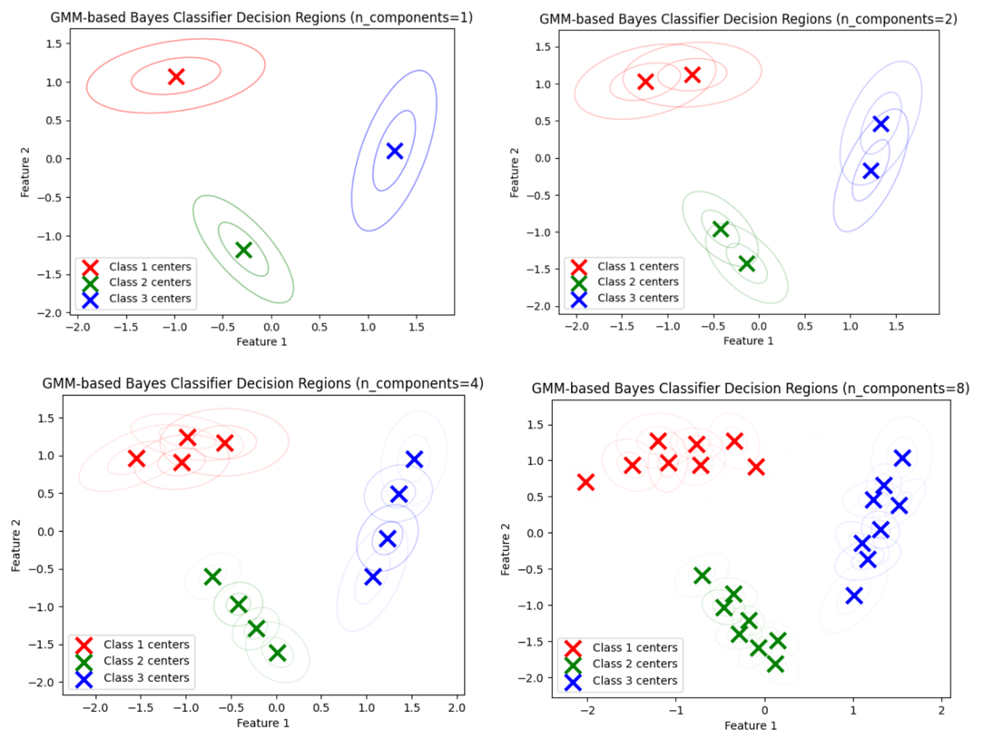
Figure 2 GMM Cluster centers for different GMM components
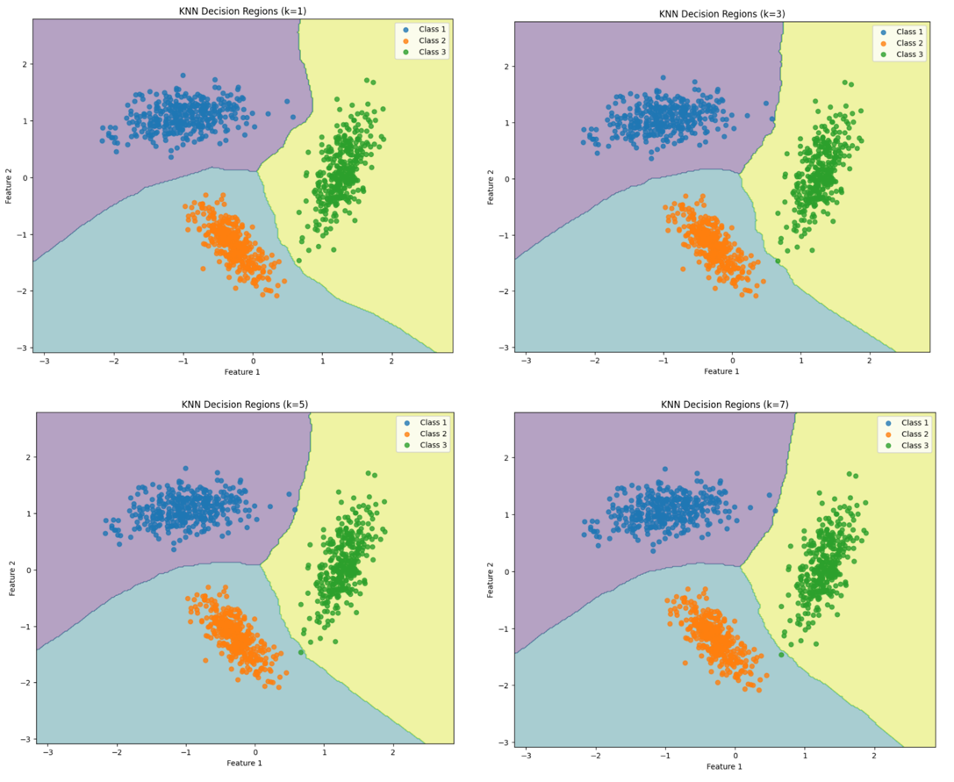
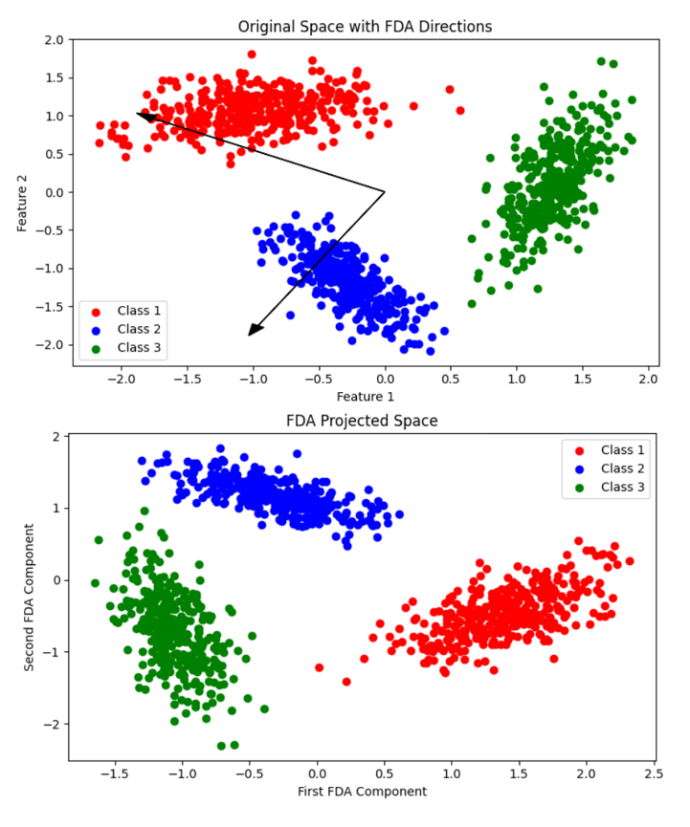
Figure 3 KNN Decision Regions
Figure 4 Original Space & Projected Space in FDA
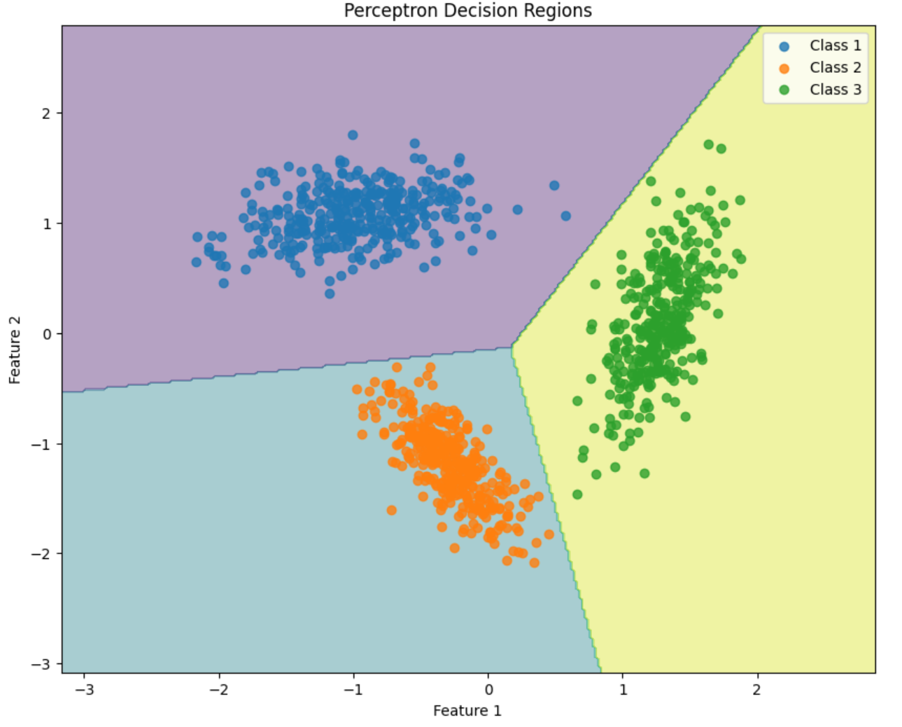
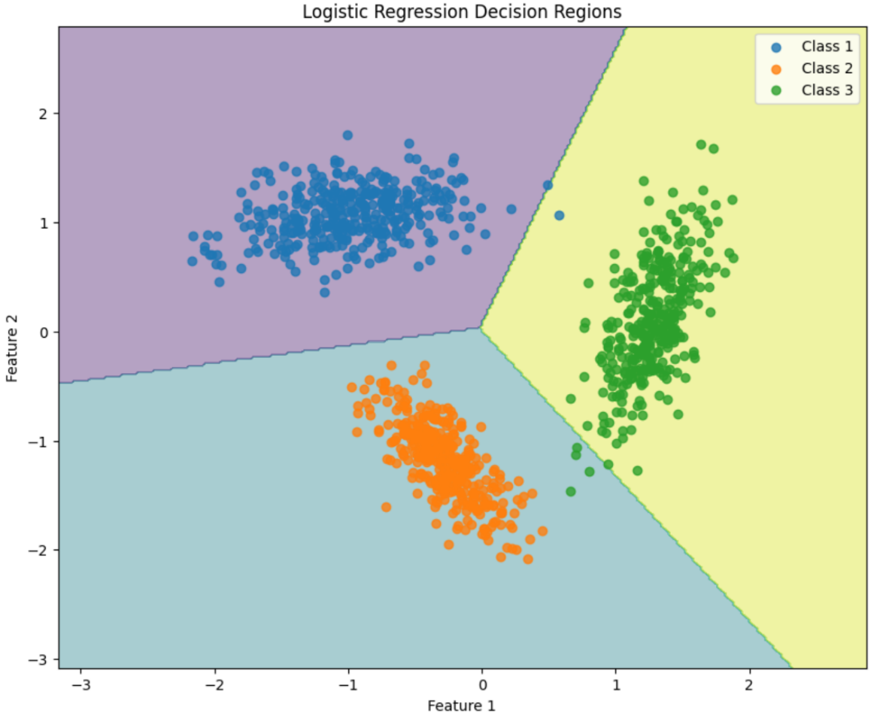
Figure 5 Perceptron Decision Regions
Figure 6 Logistic Regression Decision Regions
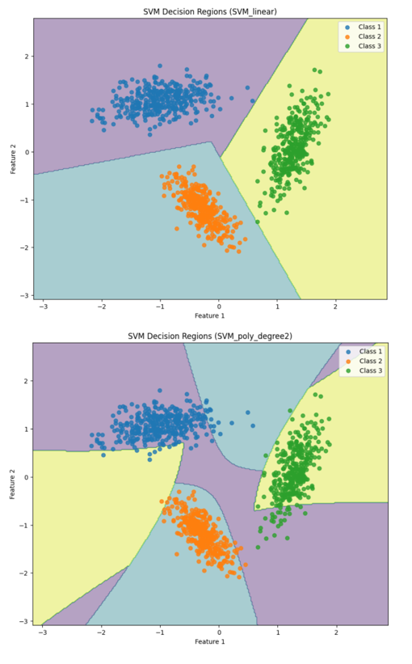
Figure 7 SVM Decision Regions
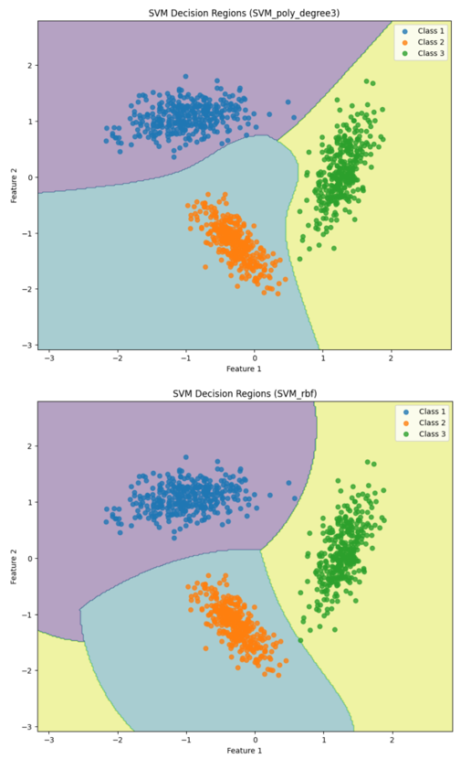
Figure 8 SVM Decision Regions

C. Plot Visualizations for Non-Linearly Separable Dataset
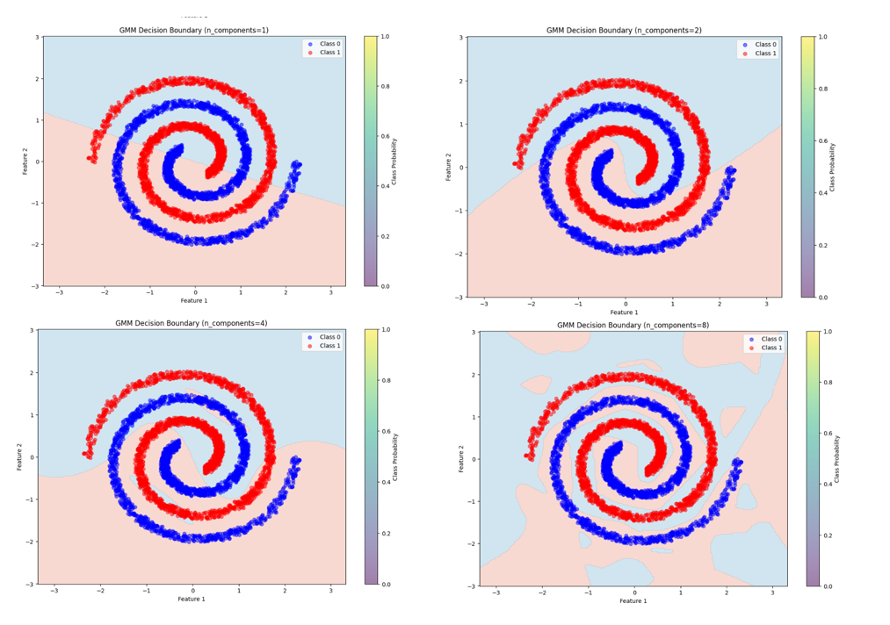
Figure 9 GMM Based Classifier Decision Regions for Components 1 to 8

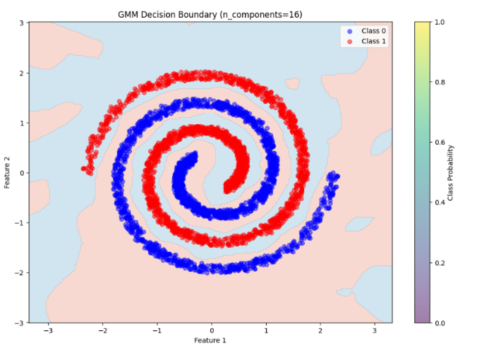
Figure 10 GMM Based Classifier Decision Regions for Components 16

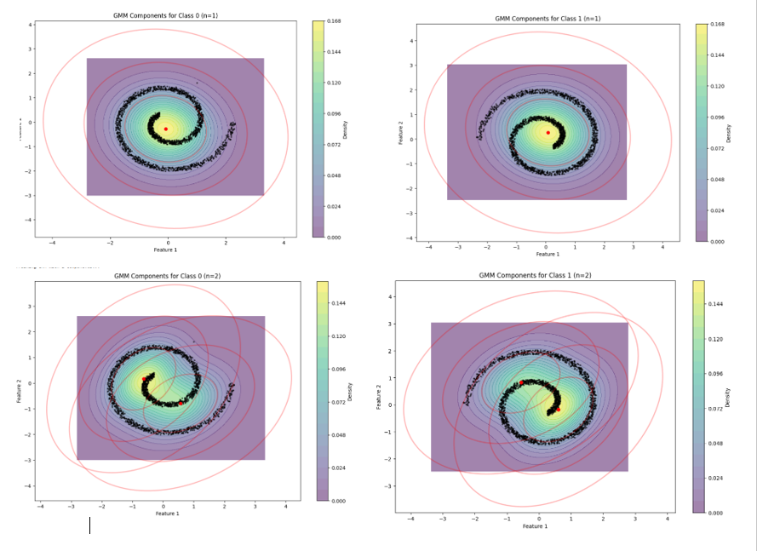
Figure 11 GMM Cluster centers for GMM Components 1 to 2
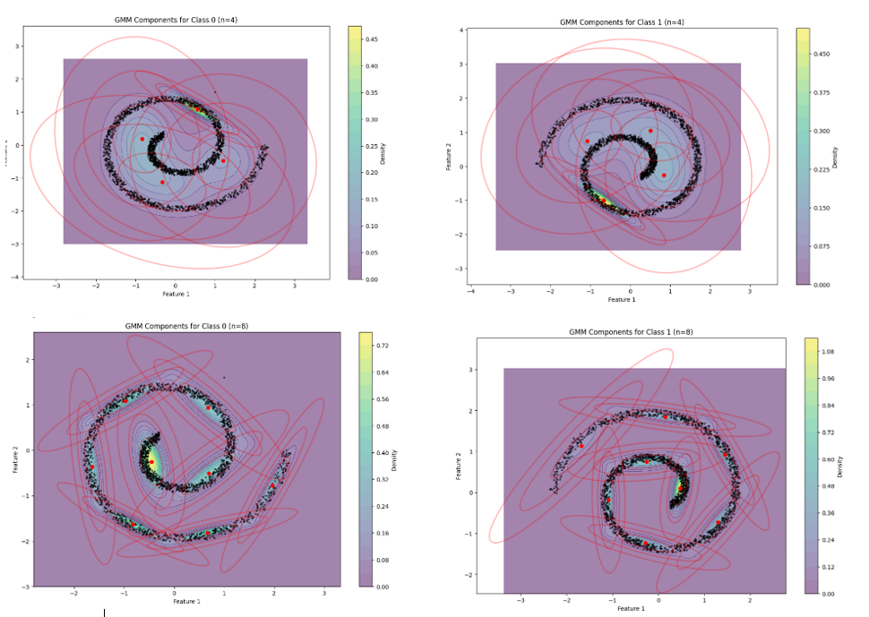
Figure 12 GMM Cluster centers for GMM Components 4 to 8
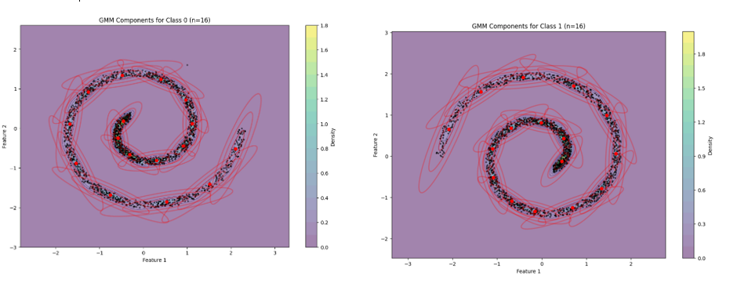
Figure 13 GMM Cluster centers for GMM Components 16

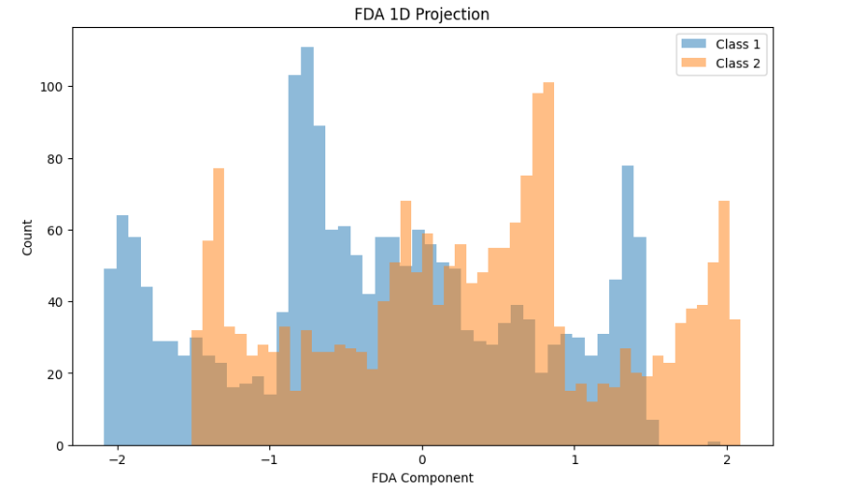
Figure 14 FDA 1D Projection
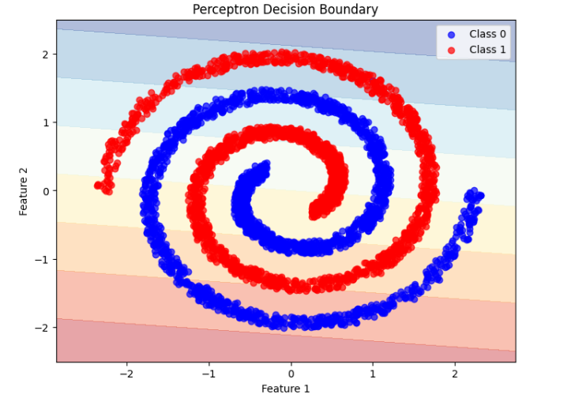
Figure 15 Perceptron Decision Boundary

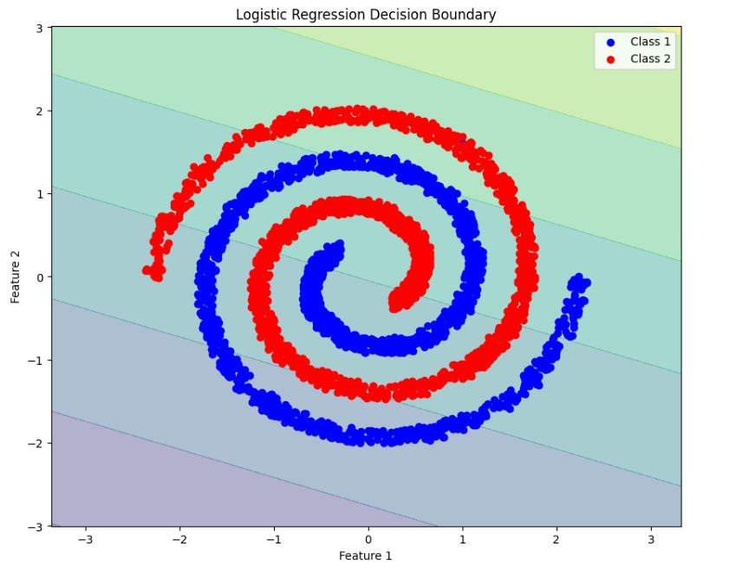
Figure 16 Logistic Regression Decision Boundary

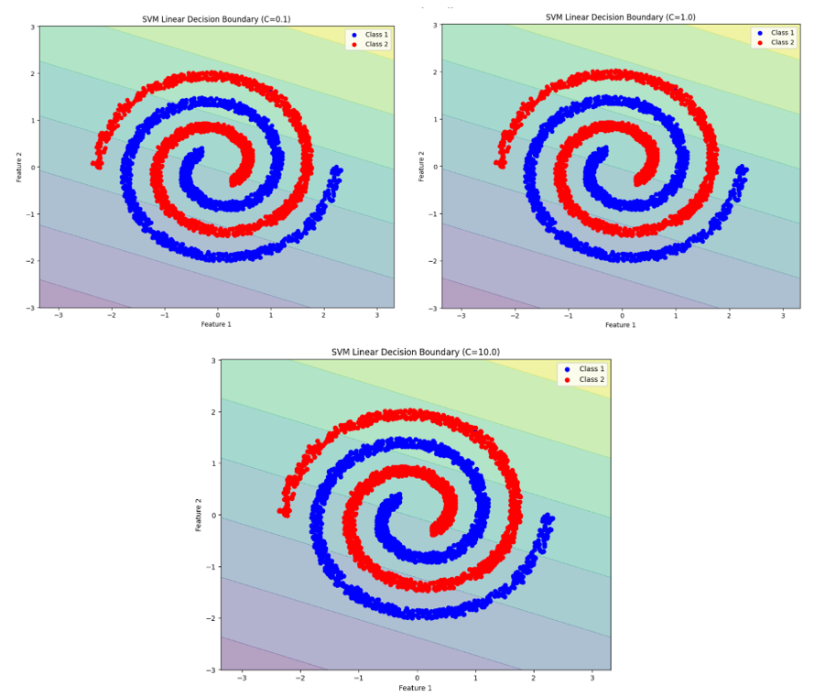
Figure 17 SVM Linear Decision Boundary

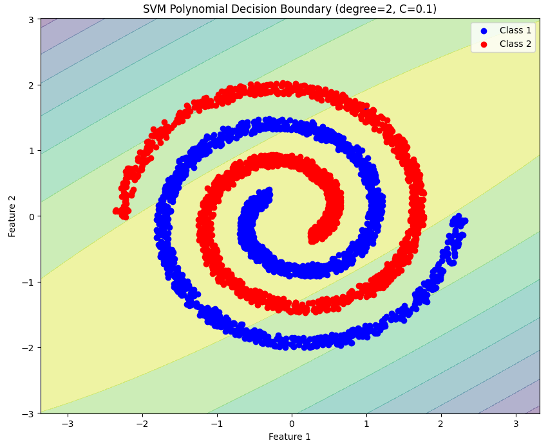
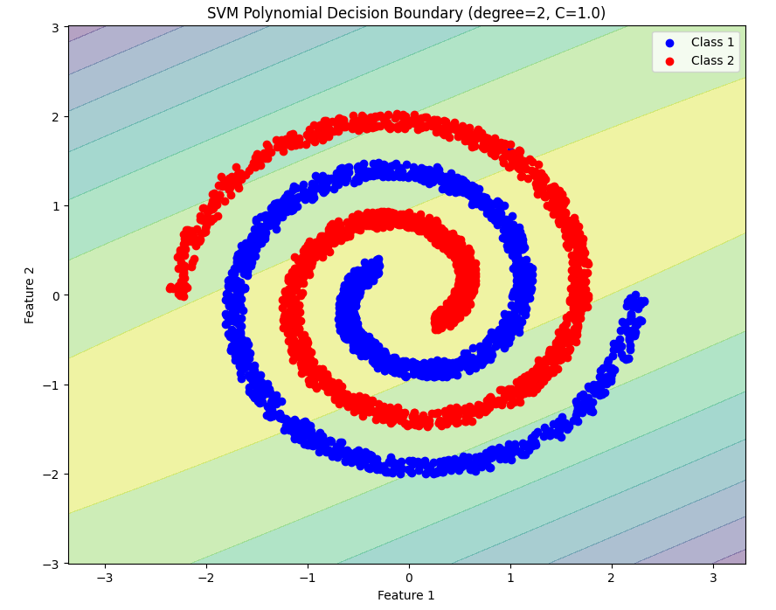
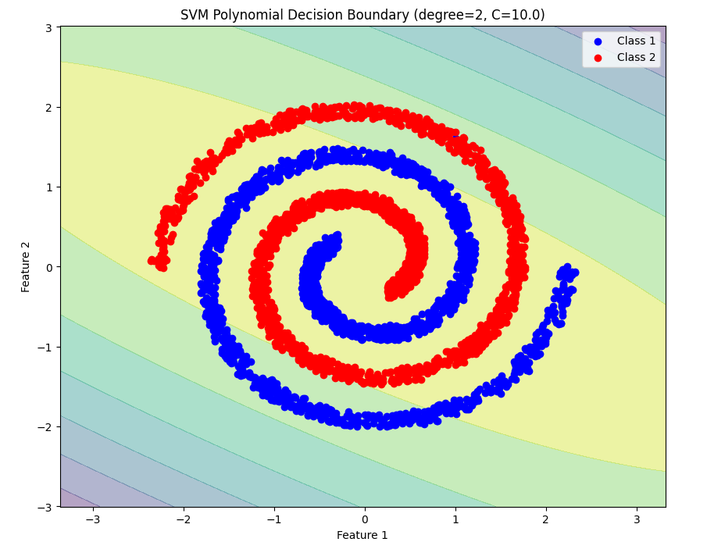
Figure 18 SVM Polynomial Decision Boundary for Degree = 2

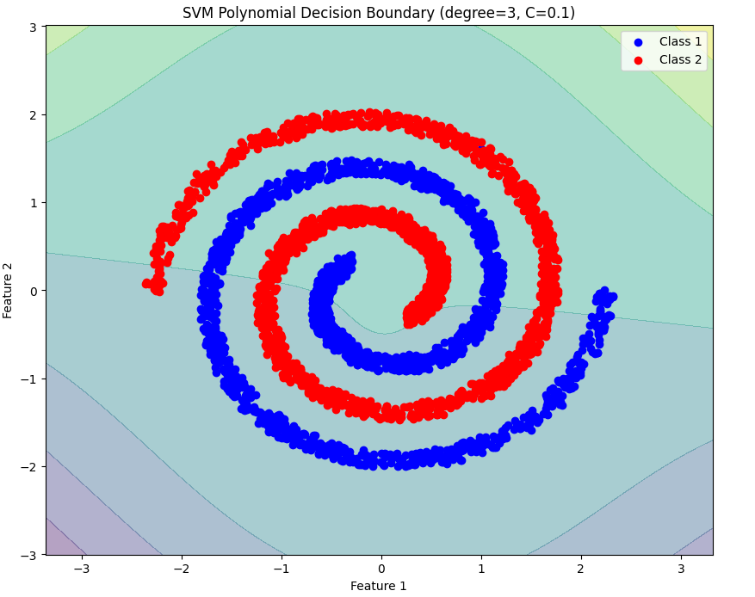
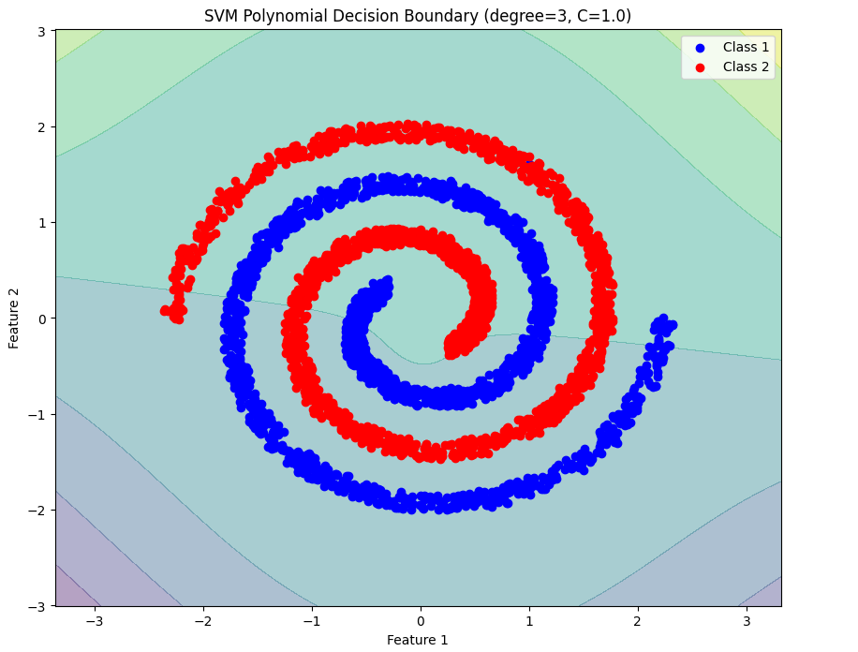
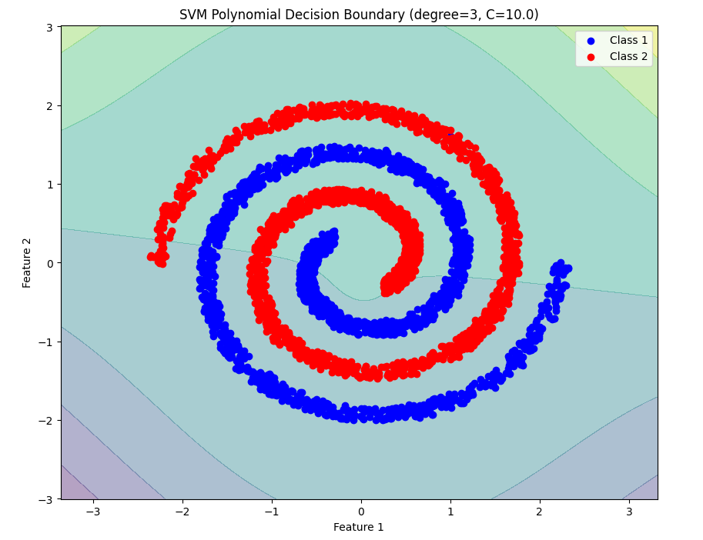
Figure 19 SVM Polynomial Decision Boundary for Degree = 3

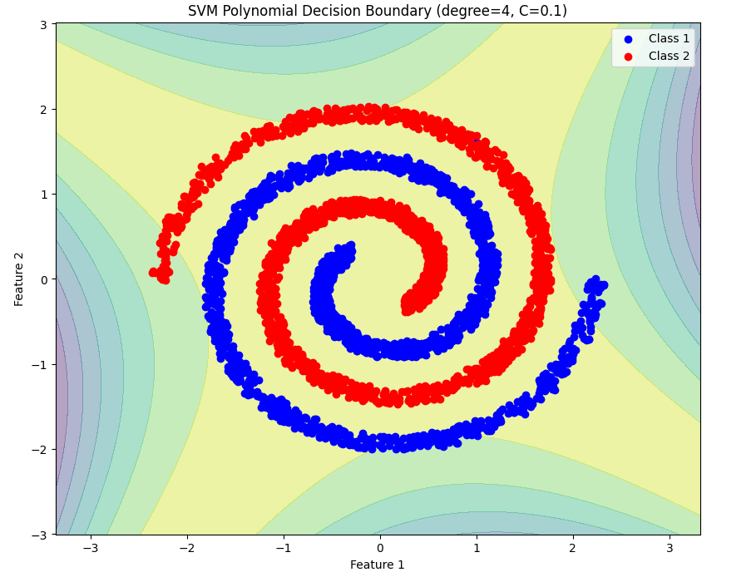
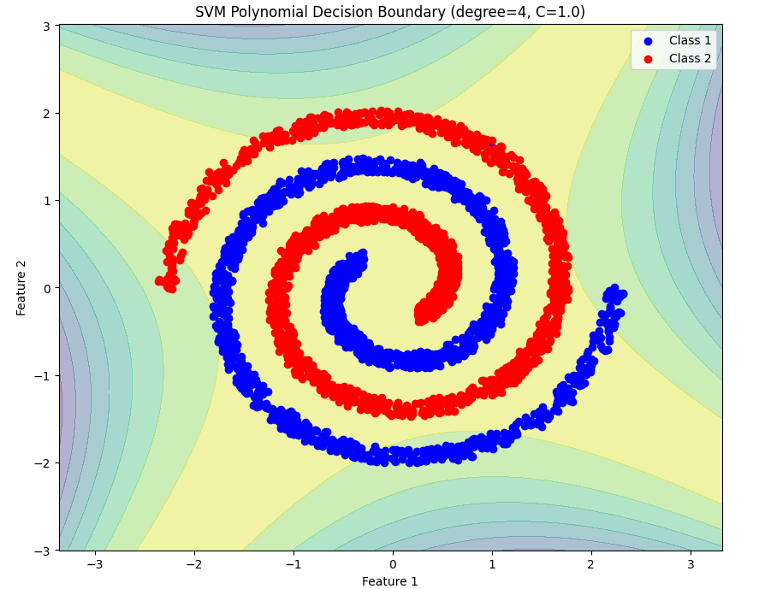
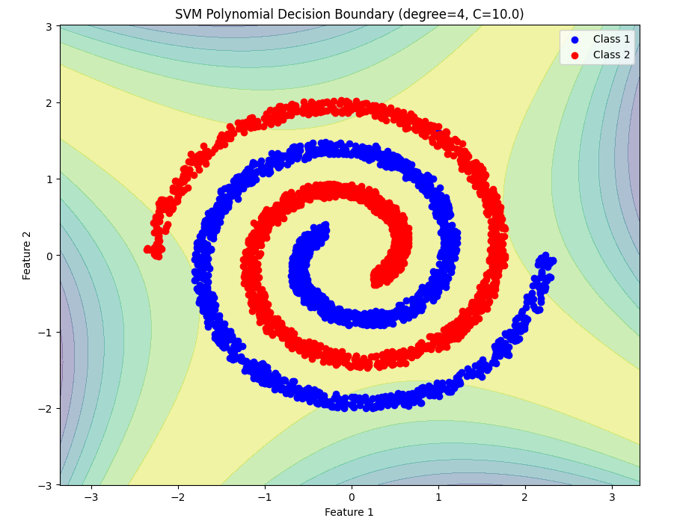
Figure 20 SVM Polynomial Decision Boundary for Degree = 4

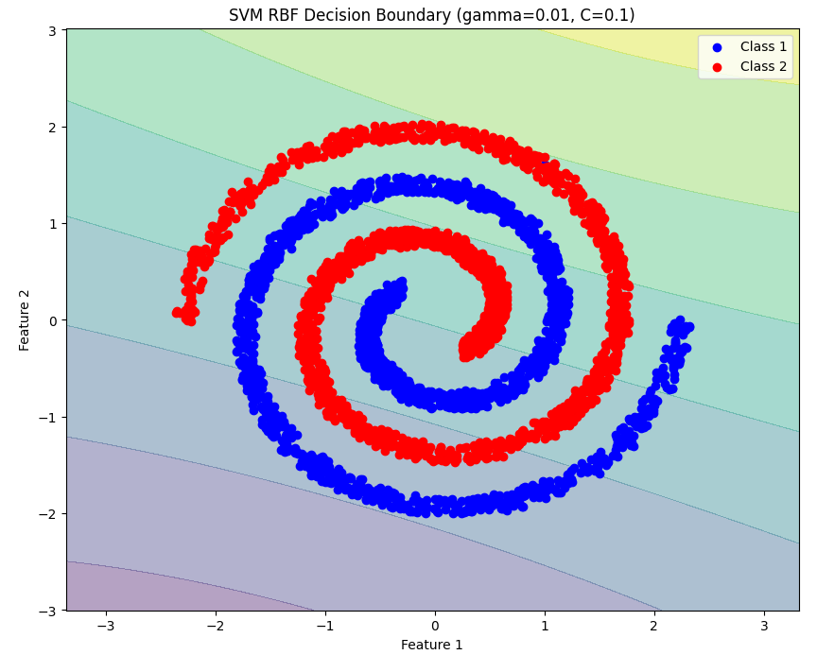
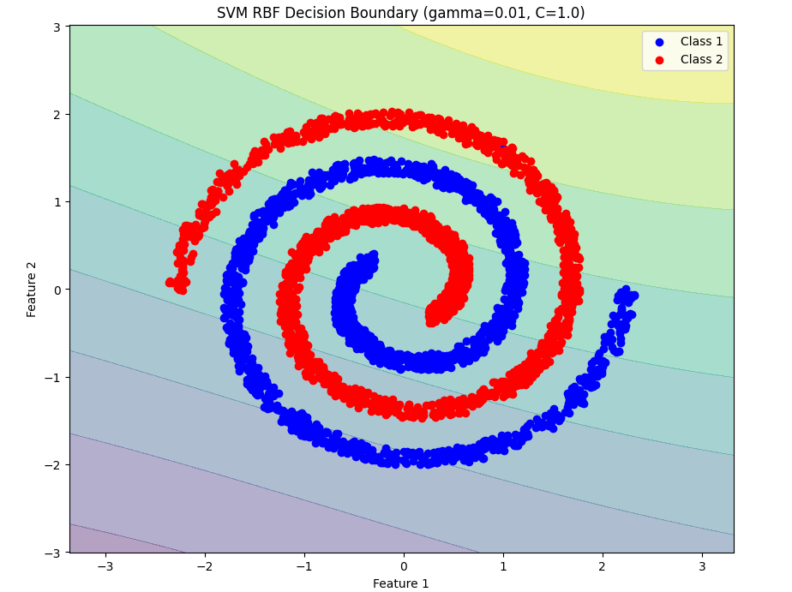
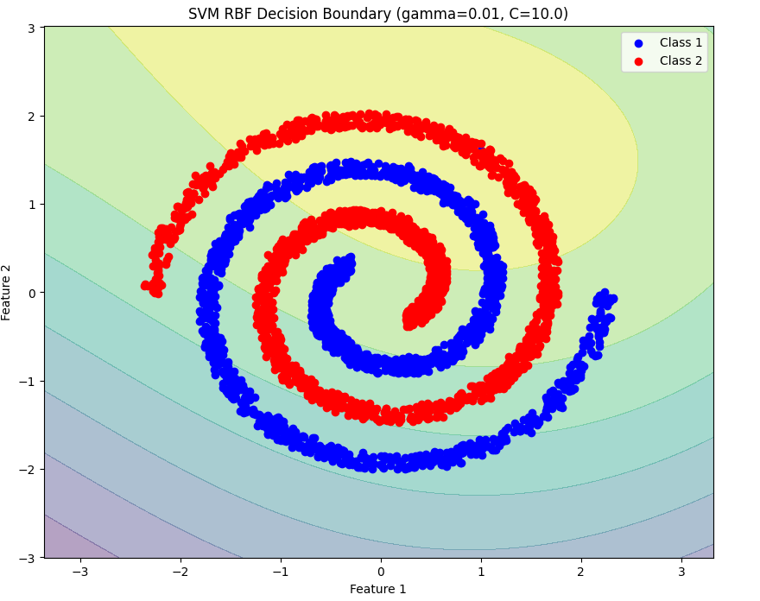
Figure 21 SVM RBF Decision Boundary (gamma =0.01)

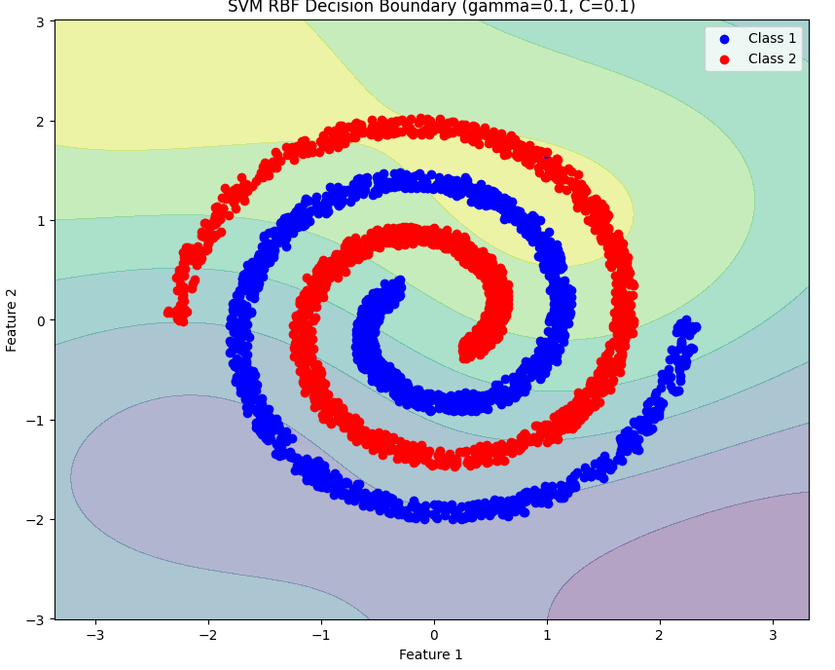
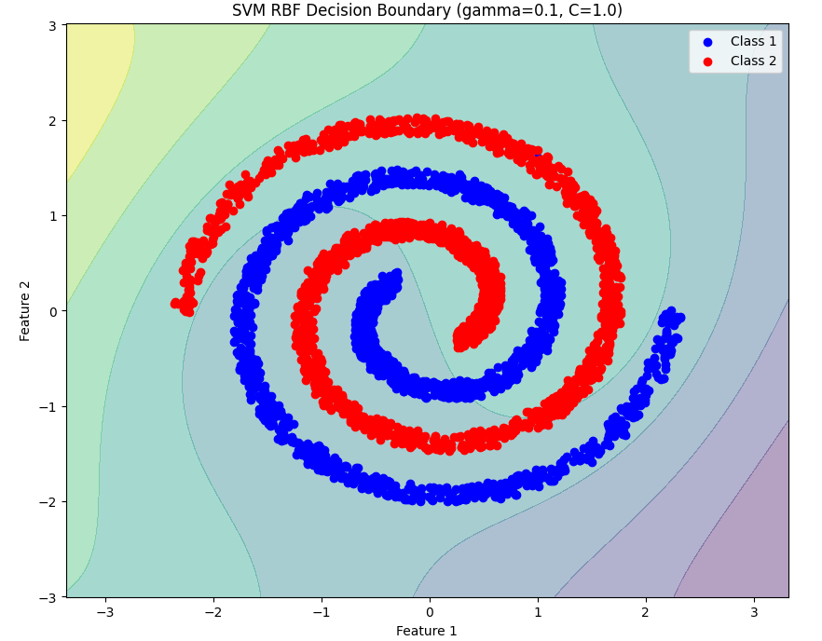
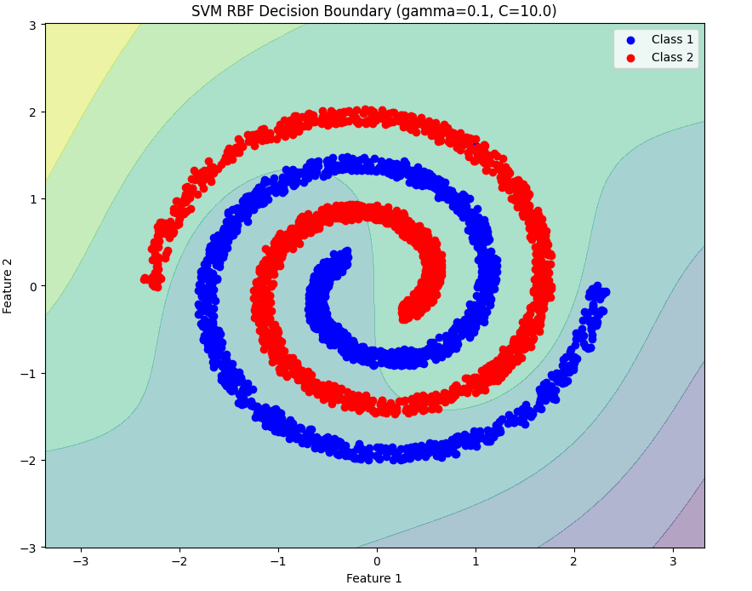
Figure 22 SVM RBF Decision Boundary (gamma =0.1)

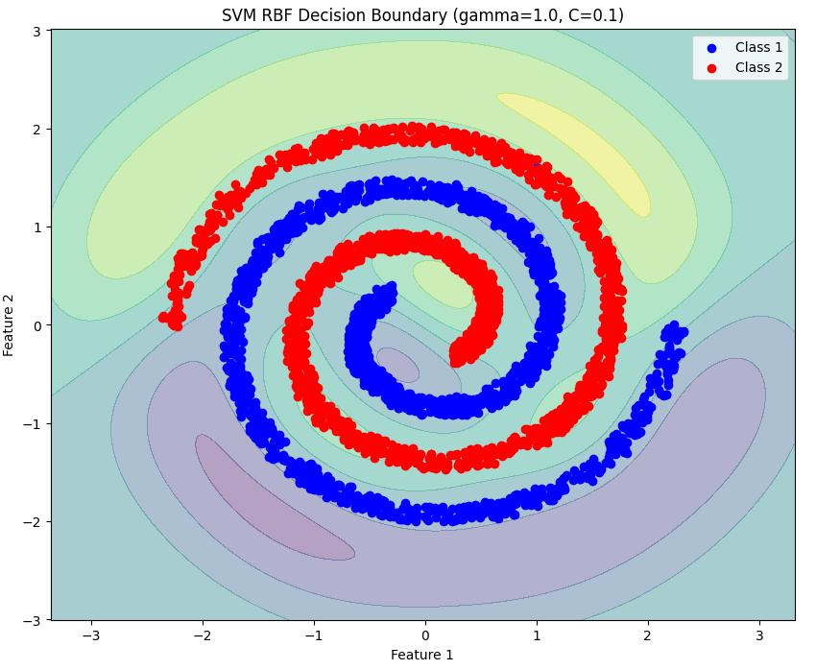
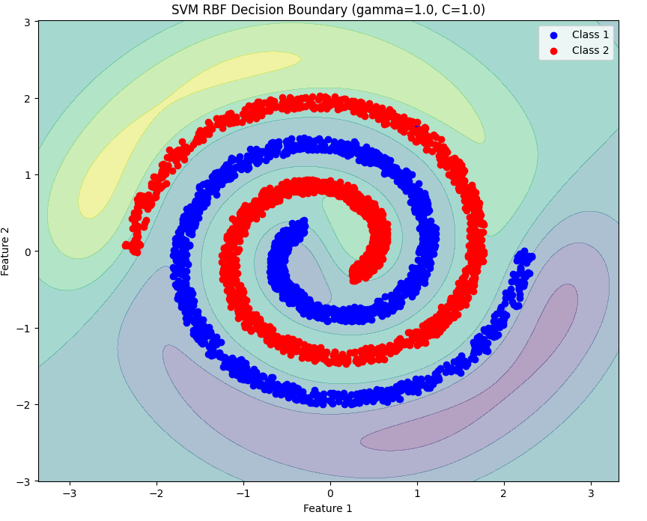
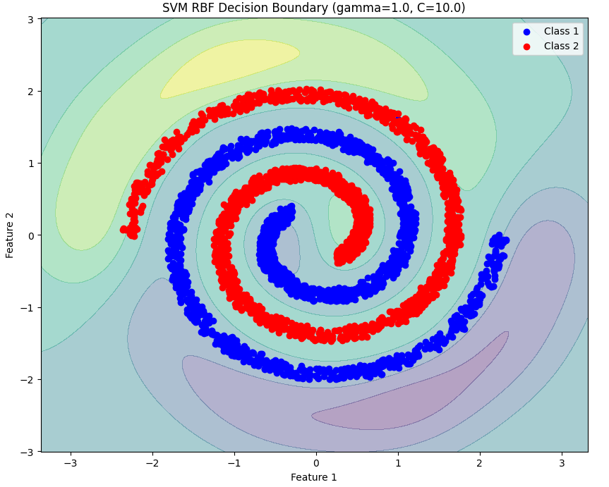
Figure 23 SVM RBF Decision Boundary (gamma =1)

D. Results and Analysis

1. Classifier Performance Metrics for Linearly Separable dataset
Confusion Matrix and Analysis: GMM-based Bayes Classifiers GMM with 1,2,4,8 components:

Actual  Predicted Class1 Class2 Class3  Class1 150 0 0  Class2 0 150 0  Class3 0 0 150  Table 1:Confusion Matrix | Class1 Class2 Class3  Precision 1.0000 1.0000 1.0000  Recall 1.0000 1.0000 1.0000  F-Measure 1.0000 1.0000 1.0000  Table 2:Analysis

Accuracy | 1.0000
Mean Precision | 1.0000
Mean Recall | 1.0000
Mean F-Measure | 1.0000
Table 3:Result
Confusion Matrix and Analysis: KNN-based Bayes Classifiers KNN with K=1 ,3,5,7 :

Actual  Predicted Class1 Class2 Class3  Class1 150 0 0  Class2 0 150 0  Class3 0 0 150  Table 4:Confusion Matrix | Class1 Class2 Class3  Precision 1.0000 1.0000 1.0000  Recall 1.0000 1.0000 1.0000  F-Measure 1.0000 1.0000 1.0000  Table 5:Analysis

Accuracy | 1.0000
Mean Precision | 1.0000
Mean Recall | 1.0000
Mean F-Measure | 1.0000
Table 6:Result
Confusion Matrix and Analysis: FDA-based Bayes Classifiers FDA with Gaussian assumption:
Actual  Predicted Class1 Class2 Class3  Class1 150 0 0  Class2 0 150 0  Class3 0 0 150  Table 7:Confusion Matrix | Class1 Class2 Class3  Precision 1.0000 1.0000 1.0000  Recall 1.0000 1.0000 1.0000  F-Measure 1.0000 1.0000 1.0000  Table 8:Analysis

Accuracy | 1.0000
Mean Precision | 1.0000
Mean Recall | 1.0000
Mean F-Measure | 1.0000
Table 9:Result
Confusion Matrix and Analysis: FDA-based Bayes Classifiers FDA with GMM:

Actual  Predicted Class1 Class2 Class3  Class1 150 0 0  Class2 0 150 0  Class3 0 0 150  Table 40:Confusion Matrix | Class1 Class2 Class3  Precision 1.0000 1.0000 1.0000  Recall 1.0000 1.0000 1.0000  F-Measure 1.0000 1.0000 1.0000  Table 11:Analysis

Accuracy | 1.0000
Mean Precision | 1.0000
Mean Recall | 1.0000
Mean F-Measure | 1.0000
Table 15:Result
Confusion Matrix and Analysis: Multiclass Perceptron Classifiers:

Actual  Predicted Class1 Class2 Class3  Class1 150 0 0  Class2 1 149 0  Class3 0 0 150  Table 64:Confusion Matrix | Class1 Class2 Class3  Precision 0.9934 1.0000 1.0000  Recall 1.0000 0.9933 1.0000  F-Measure 0.9967 0.9967 1.0000  Table 15:Analysis

Accuracy | 0.9978
Mean Precision | 0.9978
Mean Recall | 0.9978
Mean F-Measure | 0.9978
Table 16:Result

Confusion Matrix and Analysis: Multiclass Logistic Regression:

Actual  Predicted Class1 Class2 Class3  Class1 150 0 0  Class2 0 150 0  Class3 0 1 149  Table 77:Confusion Matrix | Class1 Class2 Class3  Precision 1.0000 0.9934 1.0000  Recall 1.0000 1.0000 0.9933  F-Measure 1.0000 0.9967 0.9967  Table 18:Analysis

Accuracy | 0.9978
Mean Precision | 0.9978
Mean Recall | 0.9978
Mean F-Measure | 0.9978
Table 19:Result

Confusion Matrix and Analysis: SVM Linear Classifiers:

Actual  Predicted Class1 Class2 Class3  Class1 150 0 0  Class2 0 150 0  Class3 0 0 150  Table 20:Confusion Matrix | Class1 Class2 Class3  Precision 1.0000 1.0000 1.0000  Recall 1.0000 1.0000 1.0000  F-Measure 1.0000 1.0000 1.0000  Table 81:Analysis

Accuracy | 1.0000
Mean Precision | 1.0000
Mean Recall | 1.0000
Mean F-Measure | 1.0000
Table 29:Result

Confusion Matrix and Analysis: SVM Poly_degree2 Classifiers:

Actual  Predicted Class1 Class2 Class3  Class1 139 3 8  Class2 0 148 2  Class3 0 0 140  Table 24:Confusion Matrix | Class1 Class2 Class3  Precision 0.9329 0.9801 0.9333  Recall 0.9267 0.9867 0.9333  F-Measure 0.9298 0.9834 0.9333  Table 105:Analysis

Accuracy | 0.9489
Mean Precision | 0.9488
Mean Recall | 0.9489
Mean F-Measure | 0.9488
Table 26:Result

Confusion Matrix and Analysis: SVM Poly_degree3 Classifiers:

Actual  Predicted Class1 Class2 Class3  Class1 150 0 0  Class2 0 150 0  Class3 0 0 150  Table 27:Confusion Matrix | Class1 Class2 Class3  Precision 1.0000 1.0000 1.0000  Recall 1.0000 1.0000 1.0000  F-Measure 1.0000 1.0000 1.0000  Table 118:Analysis

Accuracy | 1.0000
Mean Precision | 1.0000
Mean Recall | 1.0000
Mean F-Measure | 1.0000
Table 29:Result
Confusion Matrix and Analysis: SVM_rbf Classifiers:

Actual  Predicted Class1 Class2 Class3  Class1 150 0 0  Class2 0 150 0  Class3 0 0 150  Table 30:Confusion Matrix | Class1 Class2 Class3  Precision 1.0000 1.0000 1.0000  Recall 1.0000 1.0000 1.0000  F-Measure 1.0000 1.0000 1.0000  Table 31:Analysis

Accuracy | 1.0000
Mean Precision | 1.0000
Mean Recall | 1.0000
Mean F-Measure | 1.0000
Table 122:Result

2. Classifier Performance Metrics for Non Linearly Separable dataset
Confusion Matrix and Analysis: GMM-based Bayes Classifiers GMM with 1 component:

Predicted  Actual Class1 Class2  Class1 314 201  Class2 162 302  Table 33:Confusion Matrix | Class1 Class2  Precision 0.6597 0.6004  Recall 0.6097 0.6509  F-Measure 0.6337 0.6246  Table 34:Analysis

Accuracy | 0.6292
Mean Precision | 0.6300
Mean Recall | 0.6303
Mean F-Measure | 0.6291
Table 135:Result
Confusion Matrix and Analysis: GMM-based Bayes Classifiers GMM with 2 components:

Predicted  Actual Class1 Class2  Class1 324 191  Class2 150 314  Table 36:Confusion Matrix | Class1 Class2  Precision 0.6835 0.6218  Recall 0.6291 0.6767  F-Measure 0.6552 0.6481  Table 37:Analysis

Accuracy | 0.6517
Mean Precision
Mean Recall
Mean F-Measure
Table 148:Result

Confusion Matrix and Analysis: GMM-based Bayes Classifiers GMM with 4 components:

Predicted  Actual Class1 Class2  Class1 360 155  Class2 135 329  Table 39:Confusion Matrix | Class1 Class2  Precision 0.7273 0.6798  Recall 0.6990 0.7091  F-Measure 0.7129 0.6941  Table 40:Analysis

Accuracy | 0.7038
Mean Precision
Mean Recall
Mean F-Measure
Table 41:Result

Confusion Matrix and Analysis: GMM-based Bayes Classifiers GMM with 8 components:

Predicted  Actual Class1 Class2  Class1 515 0  Class2 5 459  Table 42:Confusion Matrix | Class1 Class2  Precision 0.9904 1.0000  Recall 1.0000 0.9892  F-Measure 0.9952 0.9946  Table 43:Analysis

Accuracy | 0.9949
Mean Precision
Mean Recall
Mean F-Measure
Table 44:Result

Confusion Matrix and Analysis: GMM-based Bayes Classifiers GMM with 16 components:

Predicted  Actual Class1 Class2  Class1 515 0  Class2 0 464  Table 45:Confusion Matrix | Class1 Class2  Precision 1.0000 1.0000  Recall 1.0000 1.0000  F-Measure 1.0000 1.0000  Table 46:Analysis

Accuracy | 1.0000
Mean Precision | 1.0000
Mean Recall | 1.0000
Mean F-Measure | 1.0000
Table 47:Result
Confusion Matrix and Analysis: KNN-based Bayes Classifiers KNN with K= 1:

Predicted  Actual Class1 Class2  Class1 374 141  Class2 110 354  Table 48:Confusion Matrix | Class1 Class2  Precision 0.7727 0.7152  Recall 0.7262 0.7629  F-Measure 0.7487 0.7383  Table 49:Analysis

Accuracy | 0.7436
Mean Precision
Mean Recall
Mean F-Measure
Table 50:Result
Confusion Matrix and Analysis: KNN-based Bayes Classifiers KNN with K= 3:

Predicted  Actual Class1 Class2  Class1 313 202  Class2 158 306  Table 515:Confusion Matrix | Class1 Class2  Precision 0.6645 0.6024  Recall 0.6078 0.6595  F-Measure 0.6349 0.6296  Table 516:Analysis

Accuracy | 0.6323
Mean Precision
Mean Recall
Mean F-Measure
Table 517:Result

Confusion Matrix and Analysis: KNN-based Bayes Classifiers KNN with K= 5:

Predicted  Actual Class1 Class2  Class1 310 205  Class2 160 304  Table 54:Confusion Matrix | Class1 Class2  Precision 0.6596 0.5972  Recall 0.6019 0.6552  F-Measure 0.6294 0.6249  Table 55:Analysis

Accuracy | 0.6272
Mean Precision
Mean Recall
Mean F-Measure
Table 56:Result
Confusion Matrix and Analysis: KNN-based Bayes Classifiers KNN with K= 7:

Predicted  Actual Class1 Class2  Class1 313 202  Class2 161 303  Table 57:Confusion Matrix | Class1 Class2  Precision 0.6603 0.6000  Recall 0.6078 0.6530  F-Measure 0.6330 0.6254  Table 58:Analysis

Accuracy | 0.6292
Mean Precision
Mean Recall
Mean F-Measure
Table 59:Result
Confusion Matrix and Analysis: FDA-based Bayes Classifiers FDA with Gaussian assumption:

Predicted  Actual Class1 Class2  Class1 302 213  Class2 156 308  Table 60:Confusion Matrix | Class1 Class2  Precision 0.6594 0.5912  Recall 0.5864 0.6638  F-Measure 0.6208 0.6264  Table 61:Analysis

Accuracy | 0.6231
Mean Precision
Mean Recall
Mean F-Measure
Table 62:Result
Confusion Matrix and Analysis: FDA-based Bayes Classifiers FDA with GMM(components=1):

Predicted  Actual Class1 Class2  Class1 314 201  Class2 162 302  Table 63:Confusion Matrix | Class1 Class2  Precision 0.6597 0.6004  Recall 0.6097 0.6509  F-Measure 0.6337 0.6246  Table 64:Analysis

Accuracy | 0.6292
Mean Precision
Mean Recall
Mean F-Measure
Table 65:Result
Confusion Matrix and Analysis: FDA-based Bayes Classifiers FDA with GMM(components=2):

Predicted  Actual Class1 Class2  Class1 293 222  Class2 135 339  Table 66:Confusion Matrix | Class1 Class2  Precision 0.6846 0.5971  Recall 0.5689 0.7091  F-Measure 0.6214 0.6483  Table 67:Analysis

Accuracy | 0.6393
Mean Precision
Mean Recall
Mean F-Measure
Table 68:Result

Confusion Matrix and Analysis: FDA-based Bayes Classifiers FDA with GMM(components=4):

Predicted  Actual Class1 Class2  Class1 350 165  Class2 123 341  Table 69:Confusion Matrix | Class1 Class2  Precision 0.7400 0.6739  Recall 0.6796 0.7349  F-Measure 0.7085 0.7031  Table 70:Analysis

Accuracy | 0.7058
Mean Precision
Mean Recall
Mean F-Measure
Table 71:Result

Confusion Matrix and Analysis: FDA-based Bayes Classifiers FDA with GMM(components=8):

Predicted  Actual Class1 Class2  Class1 355 160  Class2 133 331  Table 72:Confusion Matrix | Class1 Class2  Precision 0.7275 0.6741  Recall 0.6893 0.7134  F-Measure 0.7079 0.6932  Table 73:Analysis

Accuracy | 0.7007
Mean Precision
Mean Recall
Mean F-Measure
Table 74:Result

Confusion Matrix and Analysis: Multiclass Perceptron Classifiers:

Predicted  Actual Class1 Class2  Class1 79 436  Class2 3 461  Table 75:Confusion Matrix | Class1 Class2  Precision 0.9634 0.5139  Recall 0.1534 0.9935  F-Measure 0.2647 0.6774  Table 76:Analysis

Accuracy | 0.5516
Mean Precision
Mean Recall
Mean F-Measure
Table 77:Result

Confusion Matrix and Analysis: Multiclass Logistic Regression:

Predicted  Actual Class1 Class2  Class1 302 213  Class2 156 308  Table 78:Confusion Matrix | Class1 Class2  Precision 0.6594 0.5912  Recall 0.5864 0.6638  F-Measure 0.6208 0.6254  Table 79:Analysis

Accuracy | 0.6231
Mean Precision
Mean Recall
Mean F-Measure
Table 80:Result

Confusion Matrix and Analysis: SVM Linear Classifiers(c=0.1):

Predicted  Actual Class1 Class2  Class1 300 215  Class2 154 310  Table 81:Confusion Matrix | Class1 Class2  Precision 0.6608 0.5905  Recall 0.5825 0.6681  F-Measure 0.6192 0.6269  Table 818:Analysis

Accuracy | 0.6231
Mean Precision
Mean Recall
Mean F-Measure
Table 819:Result

Confusion Matrix and Analysis: SVM Linear Classifiers(c=1):

Predicted  Actual Class1 Class2  Class1 301 214  Class2 154 310  Table 84:Confusion Matrix | Class1 Class2  Precision 0.6615 0.5916  Recall 0.5845 0.6681  F-Measure 0.6206 0.6275  Table 85:Analysis

Accuracy | 0.6241
Mean Precision
Mean Recall
Mean F-Measure
Table 86:Result

Confusion Matrix and Analysis: SVM Linear Classifiers(c=10):

Predicted  Actual Class1 Class2  Class1 301 214  Class2 154 310  Table 87:Confusion Matrix | Class1 Class2  Precision 0.6615 0.5916  Recall 0.5845 0.6681  F-Measure 0.6206 0.6275  Table 88:Analysis

Accuracy | 0.6241
Mean Precision
Mean Recall
Mean F-Measure
Table 89:Result

Confusion Matrix and Analysis: SVM Poly_degree2 Classifiers(c= 0.1 , 1 , 10):

Predicted  Actual Class1 Class2  Class1 0 515  Class2 0 464  Table 90:Confusion Matrix | Class1 Class2  Precision 0.0000 0.4740  Recall 0.0000 1.0000  F-Measure 0.0000 0.6231  Table 91:Analysis

Accuracy | 0.4740
Mean Precision
Mean Recall
Mean F-Measure
Table 92:Result

Confusion Matrix and Analysis: SVM Poly_degree3 Classifiers (c=0.1) :

Predicted  Actual Class1 Class2  Class1 305 210  Class2 127 337  Table 93:Confusion Matrix | Class1 Class2  Precision 0.7060 0.6161  Recall 0.5922 0.7263  F-Measure 0.6441 0.6667  Table 94:Analysis

Accuracy | 0.6558
Mean Precision
Mean Recall
Mean F-Measure
Table 95:Result
Confusion Matrix and Analysis: SVM Poly_degree3 Classifiers (c=1 , 10) :

Predicted  Actual Class1 Class2  Class1 305 210  Class2 128 336  Table 96:Confusion Matrix | Class1 Class2  Precision 0.7044 0.6154  Recall 0.5922 0.7241  F-Measure 0.6435 0.6653  Table 98:Analysis

Accuracy | 0.6547
Mean Precision
Mean Recall
Mean F-Measure
Table 99:Result
Confusion Matrix and Analysis: SVM Poly_degree4 Classifiers (c=0.1) :

Predicted  Actual Class1 Class2  Class1 20 495  Class2 39 425  Table 100:Confusion Matrix | Class1 Class2  Precision 0.3390 0.4620  Recall 0.0388 0.9159  F-Measure 0.0697 0.6142  Table 101:Analysis

Accuracy | 0.4545
Mean Precision
Mean Recall
Mean F-Measure
Table 102:Result

Confusion Matrix and Analysis: SVM Poly_degree4 Classifiers (c=1) :

Predicted  Actual Class1 Class2  Class1 38 477  Class2 56 408  Table 103:Confusion Matrix | Class1 Class2  Precision 0.4043 0.4610  Recall 0.0738 0.8793  F-Measure 0.1248 0.6049  Table 104:Analysis

Accuracy | 0.4556
Mean Precision
Mean Recall
Mean F-Measure
Table 105:Result

Confusion Matrix and Analysis: SVM Poly_degree4 Classifiers (c=10) :

Predicted  Actual Class1 Class2  Class1 39 476  Class2 56 408  Table 106:Confusion Matrix | Class1 Class2  Precision 0.4105 0.4615  Recall 0.0757 0.8793  F-Measure 0.1279 0.6053  Table 107:Analysis

Accuracy | 0.4566
Mean Precision
Mean Recall
Mean F-Measure
Table 108:Result

Confusion Matrix and Analysis: SVM_rbf Classifiers( gamma=0.01, C=0.1):

Predicted  Actual Class1 Class2  Class1 300 215  Class2 155 309  Table 109:Confusion Matrix | Class1 Class2  Precision 0.6593 0.5897  Recall 0.5825 0.6659  F-Measure 0.6186 0.6255  Table 110:Analysis

Accuracy | 0.6221
Mean Precision
Mean Recall
Mean F-Measure
Table 112:Result
Confusion Matrix and Analysis: SVM_rbf Classifiers( gamma=0.01, C=1):

Predicted  Actual Class1 Class2  Class1 293 222  Class2 138 326  Table 113:Confusion Matrix | Class1 Class2  Precision 0.6798 0.5949  Recall 0.5689 0.7026  F-Measure 0.6195 0.6443  Table 114:Analysis

Accuracy | 0.6323
Mean Precision
Mean Recall
Mean F-Measure
Table 115:Result

Confusion Matrix and Analysis: SVM_rbf Classifiers( gamma=0.01, C=10):

Predicted  Actual Class1 Class2  Class1 222 293  Class2 114 350  Table 116:Confusion Matrix | Class1 Class2  Precision 0.6607 0.5443  Recall 0.4311 0.7543  F-Measure 0.5217 0.6323  Table 117:Analysis

Accuracy | 0.5843
Mean Precision
Mean Recall
Mean F-Measure
Table 118:Result

Confusion Matrix and Analysis: SVM_rbf Classifiers( gamma=0.1, C=0.1):

Predicted  Actual Class1 Class2  Class1 283 232  Class2 125 339  Table 119:Confusion Matrix | Class1 Class2  Precision 0.6636 0.5937  Recall 0.5495 0.7306  F-Measure 0.6132 0.6551  Table 120:Analysis

Accuracy | 0.6353
Mean Precision
Mean Recall
Mean F-Measure
Table 121:Result

Confusion Matrix and Analysis: SVM_rbf Classifiers( gamma=0.1, C=1):

Predicted  Actual Class1 Class2  Class1 341 274  Class2 135 329  Table 122:Confusion Matrix | Class1 Class2  Precision 0.7164 0.6541  Recall 0.6621 0.7091  F-Measure 0.6882 0.6805  Table 123:Analysis

Accuracy | 0.6844
Mean Precision
Mean Recall
Mean F-Measure
Table 124:Result

Confusion Matrix and Analysis: SVM_rbf Classifiers( gamma=0.1, C=10):

Predicted  Actual Class1 Class2  Class1 358 157  Class2 128 336  Table 125:Confusion Matrix | Class1 Class2  Precision 0.7366 0.6815  Recall 0.6951 0.7241  F-Measure 0.7153 0.7022  Table 126:Analysis

Accuracy | 0.7089
Mean Precision
Mean Recall
Mean F-Measure
Table 127:Result

Confusion Matrix and Analysis: SVM_rbf Classifiers( gamma=1, C=0.1):

Predicted  Actual Class1 Class2  Class1 453 62  Class2 39 425  Table 128:Confusion Matrix | Class1 Class2  Precision 0.9207 0.8727  Recall 0.8796 0.9159  F-Measure 0.8997 0.8938  Table 129:Analysis

Accuracy | 0.8968
Mean Precision
Mean Recall
Mean F-Measure
Table 130:Result

Confusion Matrix and Analysis: SVM_rbf Classifiers( gamma=1, C=1):

Predicted  Actual Class1 Class2  Class1 512 3  Class2 0 464  Table 131:Confusion Matrix | Class1 Class2  Precision 1.0000 0.9936  Recall 0.9942 1.0000  F-Measure 0.9971 0.9968  Table 132:Analysis

Accuracy | 0.9969
Mean Precision
Mean Recall
Mean F-Measure
Table 133:Result

Confusion Matrix and Analysis: SVM_rbf Classifiers( gamma=1, C=10):

Predicted  Actual Class1 Class2  Class1 515 0  Class2 0 464  Table 134:Confusion Matrix | Class1 Class2  Precision 1.0000 1.0000  Recall 1.0000 1.0000  F-Measure 1.0000 1.0000  Table 135:Analysis

Accuracy | 1.0000
Mean Precision | 1.0000
Mean Recall | 1.0000
Mean F-Measure | 1.0000
Table 136:Result

  - Classification accuracy.
  - Per-class and mean precision, recall, and F-measure.
  - Confusion matrices for test datasets.

2. KNN-Based Bayes Classifier Analysis
- Observations:
  - Increasing KKK resulted in smoother decision boundaries but reduced flexibility.
  - Optimal performance observed at K=3K=3K=3.

3. FDA Analysis
- Unimodal Gaussian:
  - Performed well on linearly separable data but struggled with nonlinear patterns.
- GMM:
  - Improved flexibility, capturing non-linear class structures effectively.

4. Perceptron Analysis
- Convergence was achieved faster for linearly separable data.
- Performance declined significantly on nonlinearly separable data.

5. Logistic Regression Analysis
- Showed competitive performance with smooth decision boundaries.
- Regularization helped control overfitting on nonlinear data.

6. SVM Analysis
- Kernel Comparisons:
  - Linear kernel excelled on linearly separable data.
  - Gaussian kernel outperformed on non-linear data, especially with optimized bandwidth.
  - Polynomial kernel provided a balance for moderately non-linear data.
- Optimal parameters were determined through grid search.

C. Comparative Analysis

1. Decision Region Plots
- KNN, perceptron, logistic regression, and SVM boundaries compared visually.
- Highlighted differences in decision boundaries for various methods.

2. Special Comparisons
- Perceptron vs Linear SVM:
  - SVM showed superior generalization on test data.
- FDA Dimensionality Reduction:
  - Effectively reduced dimensions for visualization and improved classifier performance.

III. Dataset 2: 3-Class Scene Image Dataset

A. Methodology

1. Bayes Classifier Using GMM
- GMMs with 1, 2, 4, and 8 mixtures were applied to the 32-dimensional BoVW dataset reduced via PCA.
- PCA reduced the dataset dimensions to 2, 5, 10, 15, and 20, retaining significant variance.
- The classification was conducted on the reduced dataset using GMM, and the effects of varying mixtures and PCA dimensions were analyzed.

2. Bayes Classifier Using KNN
- Experimented with K=1,3,5K=1, 3, 5K=1,3,5 for density estimation.
- Performance trends were analyzed.

3. FDA Implementation
- Dimensionality reduction via FDA.
- Comparison of unimodal Gaussian and GMM-based classifiers.

4. Perceptron Implementation
- Adapted perceptron for multi-class classification.

5. Logistic Regression Implementation
- Extended logistic regression for multi-class classification.

6. SVM Implementation
- Implemented SVM with one-vs-one and one-vs-all strategies for multi-class classification.
- Kernel and parameter tuning.

B. Results and Analysis

Solution Approach:
- Principle Components Analysis:
Principal component analysis (PCA) is a statistical procedure that uses an orthogonal transformation to convert a set of observations of possibly correlated variables (entities, each of which takes on various numerical values) into a set of values of linearly uncorrelated variables called principal components.

Procedure:
- Take all the training examples of all the classes.
- Compute the co-variance matrix.
- Perform eigen analysis to obtain d eigenvalues and corresponding eigenvectors where d is the dimension of one feature vector.
- Choose L eigen vectors corresponding to the L leading eigen values where L is the number of dimensions in which we our data is reduced to from d dimensions.
- Project each of the data points (training as well as test) onto these L eigenvectors to obtain the L principal components.
After reducing the dimension of the 32-dimensional BoVW representation of our images, GMM based classifications was carried out on the reduced dimensional dataset. We have carried out the GMM based classification for 1; 2; 4; 8 mixture components.

- Principle Component Analysis
- Variation Of Eigen Values
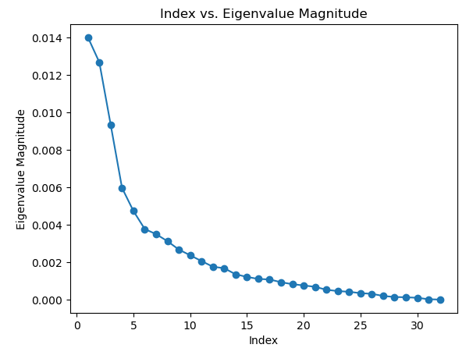
Figure 24 Variation of Eigen values

Figure 24 : Variation of Eigenvalues

We observe that around 5 - 20 eigenvalues represent almost 95 percent of variation
in our data, while other eigenvalues don't contribute much. We take the most
significant L eigen vectors corresponding to the most significant L eigen values.
The values of L considered are 2, 5, 10, 15, 21.
- 3.2 Confusion Matrix, Precision, Recall and F-measure
- Where Class1 -botanical_garden, Class2 -bus_interior and Class3 -elevator_shaft
- Confusion Matrix and Analysis: When L = 1, M = 1
Actual  Predicted Class1 Class2 Class3  Class1 34 16 0  Class2 12 32 6  Class3 13 36 1  Table 20:Confusion Matrix | Class1 Class2 Class3  Precision 0.5762 0.3809 0.1428  Recall 0.68 0.64 0.02  F-Measure 0.6238 0.4776 0.0350  Table 21:Analysis

Accuracy | 44.66%
Mean Precision | 0.3666
Mean Recall | 0.4466
Mean F-Measure | 0.3788
Table 22:Result
- Misclassified Images:
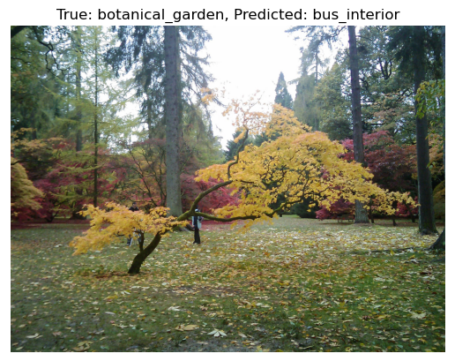
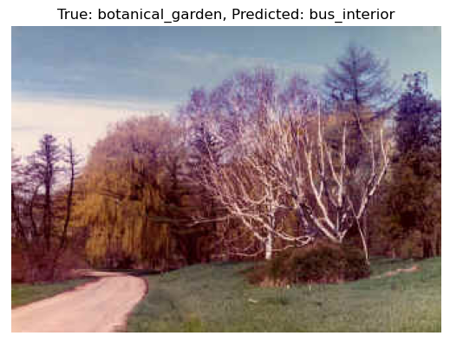
Figure 25 Misclassified Image as bus interior
Figure 26 Misclassified image as bus interior
- Confusion Matrix and Analysis: When L = 1, M = 2
Actual  Predicted Class1 Class2 Class3  Class1 30 11 9  Class2 8 27 15  Class3 11 27 12  Table 4:Confusion Matrix | Class1 Class2 Class3  Precision 0.6122 0.4153 0.3333  Recall 0.60 0.54 0.24  F-Measure 0.6060 0.4695 0.2790  Table 5:Analysis

Accuracy | 46.00%
Mean Precision | 0.4536
Mean Recall | 0.46
Mean F-Measure | 0.4515
Table 6:Result
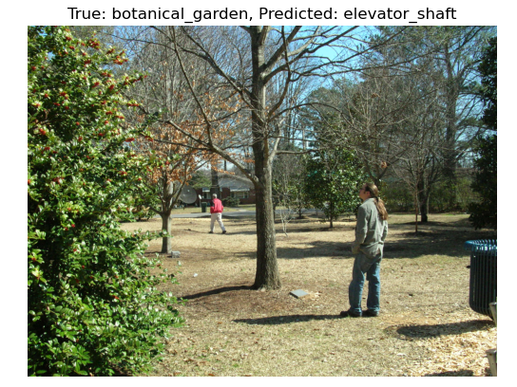
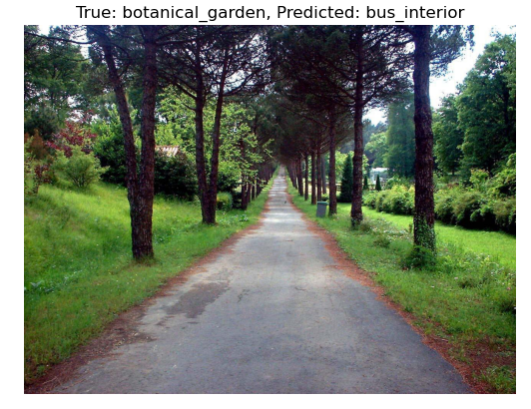
- Misclassified Images:
Figure 27 Misclassified image as elevator shaft
Figure 28 Misclassified image as bus interior

- Confusion Matrix and Analysis: When L = 1, M = 4

Actual  Predicted Class1 Class2 Class3  Class1 30 7 13  Class2 9 18 23  Class3 11 19 20  Table 7:Confusion Matrix | Class1 Class2 Class3  Precision 0.6 0.4090 0.3571  Recall 0.6 0.36 0.4  F-Measure 0.6 0.3829 0.3773  Table 8:Analysis

Accuracy | 45.33%
Mean Precision | 0.4554
Mean Recall | 0.4533
Mean F-Measure | 0.4534
Table 9:Result
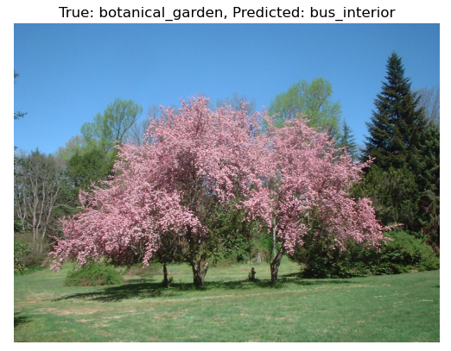
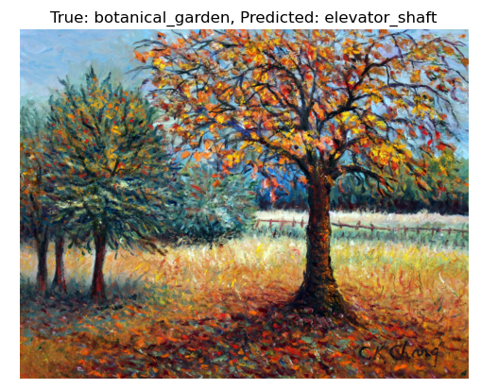
- Misclassified Images:
Figure 29 Misclassified image as bus interior
Figure 30 Misclassified image as elevator shaft

- Confusion Matrix and Analysis: When L = 1, M = 8
Actual  Predicted Class1 Class2 Class3  Class1 23 13 14  Class2 6 25 19  Class3 10 21 19  Table 230:Confusion Matrix | Class1 Class2 Class3  Precision 0.6154 0.6122 0.7222  Recall 0.8000 0.6000 0.5200  F-Measure 0.6957 0.6061 0.6047  Table 11:Analysis

Accuracy | 44.66%
Mean Precision | 0.4596
Mean Recall | 0.4466
Mean F-Measure | 0.4493
Table 12:Result
- Confusion Matrix and Analysis: When L = 2, M = 1
Actual  Predicted Class1 Class2 Class3  Class1 40 7 3  Class2 6 34 10  Class3 4 23 23  Table 243:Confusion Matrix | Class1 Class2 Class3  Precision 0.8 0.5312 0.6388  Recall 0.8 0.68 0.46  F-Measure 0.8 0.5964 0.5348  Table 14:Analysis

Accuracy | 64.66%
Mean Precision | 0.6567
Mean Recall | 0.6466
Mean F-Measure | 0.6437
Table 15:Result
- Confusion Matrix and Analysis: When L = 2, M = 2
Actual  Predicted Class1 Class2 Class3  Class1 33 10 7  Class2 5 33 12  Class3 3 24 23  Table 256:Confusion Matrix | Class1 Class2 Class3  Precision 0.8048 0.4925 0.5467  Recall 0.66 0.66 0.46  F-Measure 0.7252 0.5641 0.5  Table 17:Analysis

Accuracy | 59.33%
Mean Precision | 0.6150
Mean Recall | 0.5933
Mean F-Measure | 0.5964
Table 18:Result
- Confusion Matrix and Analysis: When L = 2, M = 4
Actual  Predicted Class1 Class2 Class3  Class1 31 12 7  Class2 5 33 12  Class3 4 22 24  Table 19:Confusion Matrix | Class1 Class2 Class3  Precision 0.775 0.4925 0.5581  Recall 0.62 0.66 0.48  F-Measure 0.6889 0.5641 0.5161  Table 20:Analysis

Accuracy | 58.67%
Mean Precision | 0.6085
Mean Recall | 0.5867
Mean F-Measure | 0.5897
Table21:Result
- Confusion Matrix and Analysis: When L = 2, M = 8
Actual  Predicted Class1 Class2 Class3  Class1 35 9 6  Class2 11 28 11  Class3 7 12 31  Table 22:Confusion Matrix | Class1 Class2 Class3  Precision 0.6603 0.5714 0.6458  Recall 0.7 0.56 0.62  F-Measure 0.6796 0.5656 0.6326  Table 263:Analysis

Accuracy | 62.66%
Mean Precision | 0.6258
Mean Recall | 0.6266
Mean F-Measure | 0.6259
Table 24:Result

- Confusion Matrix and Analysis: When L = 5, M = 1
Actual  Predicted Class1 Class2 Class3  Class1 43 4 3  Class2 1 40 9  Class3 3 18 29  Table 25:Confusion Matrix | Class1 Class2 Class3  Precision 0.9148 0.6451 0.7073  Recall 0.86 0.8 0.58  F-Measure 0.8865 0.7142 0.6373  Table 276:Analysis

Accuracy | 74.67%
Mean Precision | 0.7557
Mean Recall | 0.7466
Mean F-Measure | 0.7460
Table 27:Result
- Confusion Matrix and Analysis: When L = 5, M = 2
Actual  Predicted Class1 Class2 Class3  Class1 39 7 4  Class2 6 28 16  Class3 4 20 26  Table 28:Confusion Matrix | Class1 Class2 Class3  Precision 0.7959 0.5090 0.5652  Recall 0.78 0.56 0.52  F-Measure 0.7878 0.5333 0.5416  Table 289:Analysis

Accuracy | 62.00%
Mean Precision | 0.6234
Mean Recall | 0.62
Mean F-Measure | 0.6209
Table 30:Result
- Confusion Matrix and Analysis: When L = 5, M = 4
Actual  Predicted Class1 Class2 Class3  Class1 37 2 11  Class2 7 22 21  Class3 4 12 34  Table 31:Confusion Matrix | Class1 Class2 Class3  Precision 0.7708 0.6111 0.5151  Recall 0.74 0.44 0.68  F-Measure 0.7551 0.5116 0.5862  Table 31:Analysis

Accuracy | 62.00%
Mean Precision | 0.6323
Mean Recall | 0.62
Mean F-Measure | 0.6176
Table 32:Result

- Confusion Matrix and Analysis: When L = 5, M = 8
Actual  Predicted Class1 Class2 Class3  Class1 43 3 4  Class2 19 23 8  Class3 22 14 14  Table 33:Confusion Matrix | Class1 Class2 Class3  Precision 0.5119 0.575 0.5384  Recall 0.86 0.46 0.28  F-Measure 0.6417 0.5111 0.3684  Table 34:Analysis

Accuracy | 53.33%
Mean Precision | 0.5417
Mean Recall | 0.5333
Mean F-Measure | 0.5071
Table 295:Result
- Confusion Matrix and Analysis: When L = 10, M = 1
Actual  Predicted Class1 Class2 Class3  Class1 39 9 2  Class2 6 33 11  Class3 6 17 27  Table 36:Confusion Matrix | Class1 Class2 Class3  Precision 0.7647 0.5593 0.675  Recall 0.78 0.66 0.54  F-Measure 0.7722 0.6055 0.6  Table 37:Analysis

Accuracy | 66.00%
Mean Precision | 0.6663
Mean Recall | 0.66
Mean F-Measure | 0.6592
Table 308:Result
- Confusion Matrix and Analysis: When L = 10, M = 2
Actual  Predicted Class1 Class2 Class3  Class1 39 10 1  Class2 5 32 13  Class3 7 24 19  Table 39:Confusion Matrix | Class1 Class2 Class3  Precision 0.7647 0.4848 0.5757  Recall 0.78 0.64 0.38  F-Measure 0.7722 0.5517 0.4578  Table 40:Analysis

Accuracy | 60.00%
Mean Precision | 0.6048
Mean Recall | 0.6
Mean F-Measure | 0.5939
Table 41:Result

- Confusion Matrix and Analysis: When L = 10, M = 4
Actual  Predicted Class1 Class2 Class3  Class1 35 13 2  Class2 15 24 11  Class3 16 19 15  Table 42:Confusion Matrix | Class1 Class2 Class3  Precision 0.5303 0.4285 0.5357  Recall 0.7 0.48 0.3  F-Measure 0.6034 0.4528 0.3846  Table 43:Analysis

Accuracy | 49.33%
Mean Precision | 0.4981
Mean Recall | 0.4933
Mean F-Measure | 0.4802
Table 44:Result
- Confusion Matrix and Analysis: When L = 10, M = 8
Actual  Predicted Class1 Class2 Class3  Class1 16 6 28  Class2 3 8 39  Class3 1 8 41  Table 45:Confusion Matrix | Class1 Class2 Class3  Precision 0.6154 0.6122 0.7222  Recall 0.8000 0.6000 0.5200  F-Measure 0.6957 0.6061 0.6047  Table 46:Analysis

Accuracy | 43.33%
Mean Precision | 0.5144
Mean Recall | 0.4333
Mean F-Measure | 0.3994
Table 47:Result
- Confusion Matrix and Analysis: When L = 15, M = 1
Actual  Predicted Class1 Class2 Class3  Class1 43 5 2  Class2 7 31 12  Class3 5 16 29  Table 48:Confusion Matrix | Class1 Class2 Class3  Precision 0.7818 0.5961 0.6744  Recall 0.86 0.62 0.58  F-Measure 0.8190 0.6078 0.6236  Table 49:Analysis

Accuracy | 68.66%
Mean Precision | 0.6841
Mean Recall | 0.6866
Mean F-Measure | 0.6835
Table 50:Result
- Confusion Matrix and Analysis: When L = 15, M = 2
Actual  Predicted Class1 Class2 Class3  Class1 47 2 1  Class2 9 24 17  Class3 7 15 28  Table 531:Confusion Matrix | Class1 Class2 Class3  Precision 0.7460 0.5853 0.6086  Recall 0.94 0.48 0.56  F-Measure 0.8318 0.5274 0.5833  Table 5532:Analysis

Accuracy | 66.00%
Mean Precision | 0.6466
Mean Recall | 0.66
Mean F-Measure | 0.6475
Table 533:Result
- Confusion Matrix and Analysis: When L = 15, M = 4
Actual  Predicted Class1 Class2 Class3  Class1 33 6 11  Class2 5 35 10  Class3 1 24 25  Table 54:Confusion Matrix | Class1 Class2 Class3  Precision 0.8461 0.5384 0.5434  Recall 0.66 0.7 0.5  F-Measure 0.7415 0.6086 0.5208  Table 55:Analysis

Accuracy | 62.00%
Mean Precision | 0.6426
Mean Recall | 0.62
Mean F-Measure | 0.6237
Table 56:Result
- Confusion Matrix and Analysis: When L = 15, M = 8
Actual  Predicted Class1 Class2 Class3  Class1 45 4 1  Class2 20 23 7  Class3 13 10 27  Table 57:Confusion Matrix | Class1 Class2 Class3  Precision 0.5769 0.6216 0.7714  Recall 0.9 0.46 0.54  F-Measure 0.7031 0.5287 0.6352  Table 58:Analysis

Accuracy | 63.33%
Mean Precision | 0.6566
Mean Recall | 0.6333
Mean F-Measure | 0.6223
Table 59:Result

- Confusion Matrix and Analysis: When L = 20, M = 1
Actual  Predicted Class1 Class2 Class3  Class1 42 5 3  Class2 7 31 12  Class3 5 15 30  Table 60:Confusion Matrix | Class1 Class2 Class3  Precision 0.7777 0.6078 0.6667  Recall 0.84 0.62 0.6  F-Measure 0.8076 0.6138 0.6315  Table 61:Analysis

Accuracy | 68.66%
Mean Precision | 0.6840
Mean Recall | 0.6866
Mean F-Measure | 0.6843
Table 62:Result
- Confusion Matrix and Analysis: When L = 20, M = 2
Actual  Predicted Class1 Class2 Class3  Class1 42 7 1  Class2 6 27 17  Class3 6 17 27  Table 63:Confusion Matrix | Class1 Class2 Class3  Precision 0.7778 0.5294 0.6  Recall 0.84 0.54 0.54  F-Measure 0.8076 0.5346 0.5684  Table 64:Analysis

Accuracy | 64.00%
Mean Precision | 0.6357
Mean Recall | 0.64
Mean F-Measure | 0.6369
Table 65:Result
- Confusion Matrix and Analysis: When L = 20, M = 4
Actual  Predicted Class1 Class2 Class3  Class1 11 1 38  Class2 1 4 45  Class3 0 4 46  Table 66:Confusion Matrix | Class1 Class2 Class3  Precision 0.9166 0.4444 0.3567  Recall 0.22 0.08 0.92  F-Measure 0.3548 0.1355 0.5139  Table 67:Analysis

Accuracy | 40.67%
Mean Precision | 0.5725
Mean Recall | 0.4067
Mean F-Measure | 0.3347
Table 68:Result

- Confusion Matrix and Analysis: When L = 20, M = 8
Actual  Predicted Class1 Class2 Class3  Class1 46 3 1  Class2 12 32 6  Class3 13 23 14  Table 69:Confusion Matrix | Class1 Class2 Class3  Precision 0.6478 0.5517 0.6667  Recall 0.92 0.64 0.28  F-Measure 0.7603 0.5925 0.3943  Table 70:Analysis

Accuracy | 61.33%
Mean Precision | 0.6220
Mean Recall | 0.6133
Mean F-Measure | 0.5824
Table 71:Result

3 Solution Approach
- Density estimated from K-nearest neighbour (KNN) method:
The K-Nearest Neighbor (KNN) method for density estimation is a non-parametric technique used to estimate the probability density of a given point in a dataset. Unlike parametric methods, KNN does not assume a specific functional form (e.g., Gaussian) for the data distribution, making it flexible for estimating densities in complex datasets.

Procedure:
- A region with many data points (high density) will have neighbors closer to $x$, leading to a higher density estimate.
- A region with few data points (low density) will have neighbors farther from $x$, resulting in a lower density estimate.
- Compute the distance of $x$ from every point in the dataset using a distance metric (e.g., Euclidean distance):
$$d\left(x,x_{i}\right)=\sqrt{\sum_{j=1}^{d}{{\left(x_{j}-x_{ij}\right)}^{2}}}$$

3.1 Results
1. Confusion Matrix and Analysis: when K=1
Actual  Predicted Class1 Class2 Class3  Class1 31 10 9  Class2 6 30 14  Class3 4 19 27  Table 72:Confusion Matrix | Class1 Class2 Class3  Precision 0.7560 0.5084 0.54  Recall 0.62 0.6 0.54  F-Measure 0.6813 0.5504 0.54  Table73:Analysis

Accuracy | 58.67%
Mean Precision | 0.6015
Mean Recall | 0.5866
Mean F-Measure | 0.5905
Table 74:Result
2. Confusion Matrix and Analysis: when K=3
Actual  Predicted Class1 Class2 Class3  Class1 32 8 10  Class2 3 31 16  Class3 1 17 32  Table 75:Confusion Matrix | Class1 Class2 Class3  Precision 0.8889 0.5535 0.5517  Recall 0.64 0.62 0.64  F-Measure 0.7441 0.5849 0.5925  Table 75:Analysis

Accuracy | 63.33%
Mean Precision | 0.6647
Mean Recall | 0.6333
Mean F-Measure | 0.6405
Table 76:Result
3. Confusion Matrix and Analysis: when K=5
Actual  Predicted Class1 Class2 Class3  Class1 33 8 9  Class2 3 31 16  Class3 1 15 34  Table 77:Confusion Matrix | Class1 Class2 Class3  Precision 0.8918 0.5740 0.5762  Recall 0.66 0.62 0.68  F-Measure 0.7586 0.5961 0.6238  Table 78:Analysis

Accuracy | 65.33%
Mean Precision | 0.6807
Mean Recall | 0.6533
Mean F-Measure | 0.6595
Table 79:Result
4. Confusion Matrix and Analysis: when K=7
Actual  Predicted Class1 Class2 Class3  Class1 34 6 10  Class2 3 29 18  Class3 1 15 34  Table 80:Confusion Matrix | Class1 Class2 Class3  Precision 0.8947 0.58 0.5483  Recall 0.68 0.58 0.68  F-Measure 0.7727 0.58 0.6071  Table81:Analysis

Accuracy | 64.66%
Mean Precision | 0.6743
Mean Recall | 0.6466
Mean F-Measure | 0.6732
Table 82:Result

Solution Approach
- Apply Fisher linear discriminant analysis (FDA)
Fisher Linear Discriminant Analysis (FDA) is a dimensionality reduction technique primarily used for supervised classification problems. It finds a linear combination of features that maximizes the separation between multiple classes by projecting high-dimensional data into a lower-dimensional space (often 1D or 2D).

Procedure:
- $A dataset with Nsamples, each represented as a ddd-dimensional vector xxx, along with class labels.$
- $Compute the within class scatter matrix S_{W}​and Compute the between-class scatter matrix S_{B}.$
- Solve the generalized eigenvalue problem:
$$S_{W}^{-1}S_{B}w=λw$$
- Select the eigenvectors corresponding to the $largest c-1 eigenvalues$.
- Project the original data $x$ onto the reduced space using the projection $matrix W formed$y the selected eigenvectors:
$$x^{'}=W^{T}x$$

4.1 Results
1. bayes Classifier using Unimodal Gaussian
Actual  Predicted Class1 Class2 Class3  Class1 41 4 5  Class2 2 35 13  Class3 1 19 30  Table 83:Confusion Matrix | Class1 Class2 Class3  Precision 0.9318 0.6034 0.625  Recall 0.82 0.7 0.6  F-Measure 0.8723 0.6481 0.6122  Table 84:Analysis

Accuracy | 70.66%
Mean Precision | 0.7200
Mean Recall | 0.7066
Mean F-Measure | 0.7109
Table 85:Result

2. bayes Classifier using Gaussian mixer model (GMM)
Actual  Predicted Class1 Class2 Class3  Class1 38 5 7  Class2 2 33 15  Class3 1 17 32  Table 86:Confusion Matrix | Class1 Class2 Class3  Precision 0.9268 0.6 0.5925  Recall 0.76 0.66 0.64  F-Measure 0.8351 0.6285 0.6153  Table 87:Analysis

Accuracy | 68.66%
Mean Precision | 0.7064
Mean Recall | 0.6866
Mean F-Measure | 0.6930
Table 88:Result

Solution Approach
- Perceptron Based Classifier

The Perceptron-based classifier is one of the simplest types of artificial neural networks. It is primarily used for binary classification and operates by finding a linear decision boundary that separates two classes. When extended to multi-class classification, strategies like One-vs-Rest or One-vs-One are used.

Procedure:
To extend the Perceptron to multi-class classification, the One-vs-Rest (OvR) approach is commonly used:
- Train a separate binary Perceptron for each class.
- Treat the current class as the positive class and all other classes as the negative class.
- Initialize one weight $vector w_{i} for each class i,wherei=1,…,c$ (for class classification).
- Initialize the corresponding bias terms $b_{i}$​ to 0.

5.1 Results
1. Multi-Class Perceptron Classifier
Actual  Predicted Class1 Class2 Class3  Class1 22 3 25  Class2 1 20 29  Class3 0 7 43  Table 89:Confusion Matrix | Class1 Class2 Class3  Precision 0.9556 0.6667 0.4432  Recall 0.44 0.4 0.86  F-Measure 0.6027 0.5 0.5850  Table 90:Analysis

Accuracy | 56.67%
Mean Precision | 0.6888
Mean Recall | 0.5667
Mean F-Measure | 0.7562
Table 91:Result

Solution Approach
- Logistic Regression Classifier

Logistic regression is a supervised learning algorithm primarily used for binary classification, although it can be extended to multi-class classification. It models the probability that a given input $x$ belongs to a particular class using a logistic function (sigmoid).

Procedure:
- A dataset with input feature vectors $x$ binary labels $y ∈\{0, 1\}$
- Initialize the weight vector $w$ and bias b to zeros or small random values.
- For each sample $x_{i}$ compute the linear combination zzz and apply the sigmoid function:
$$z_{i}=w⋅x_{i}+b, P\left(y=1 | x_{i}\right)=σ\left(z_{i}\right)$$
- Use the log-loss (negative log-likelihood) as the cost function:
$$L=-\frac{1}{n}\sum_{i=1}^{n}{\left[y_{i}\log\left(P\left(y=1 | x_{i}\right)\right)+\left(1-y_{i}\right)\log\left(1-P\left(y=1 | x_{i}\right)\right)\right]}$$
- Compute gradients of the loss with respect to w and b:
$$\frac{∂L}{∂w}=-\frac{1}{n}\sum_{i=1}^{n}{\left(y_{i}-P\left(y=1 | x_{i}\right)\right)x_{i}}$$
$$\frac{∂L}{∂b}=-\frac{1}{n}\sum_{i=1}^{n}{\left(y_{i}-P\left(y=1 | x_{i}\right)\right)}$$
- Update parameters:
$$w←w-η⋅\frac{∂L}{∂w}$$

$$b←b-η⋅\frac{∂L}{∂b}$$

6.1 Results
1. Multi-Class Logistic Regression Classifier
Actual  Predicted Class1 Class2 Class3  Class1 39 6 5  Class2 2 35 13  Class3 2 19 29  Table 92:Confusion Matrix | Class1 Class2 Class3  Precision 0.9069 0.5833 0.6170  Recall 0.78 0.7 0.58  F-Measure 0.8387 0.6363 0.5979  Table 93:Analysis

Accuracy | 68.67%
Mean Precision | 0.7024
Mean Recall | 0.6866
Mean F-Measure | 0.6910
Table 94:Result

Solution Approach
- SVM based Classifier

Support Vector Machines (SVM) are supervised learning algorithms used for classification and regression. They aim to find the optimal hyperplane that separates data points of different classes with the maximum margin. SVMs are versatile due to the use of kernel functions, enabling both linear and non-linear decision boundaries.

Procedure:
- The goal is to maximize the margin between the hyperplane and the nearest data points (support vectors).
- Minimize:
$$\frac{1}{2}{\left|\left|w\right|\right|}^{2}$$
- Subject to constraints:
$$y_{i}\left(w⋅x_{i}+b\right)≥1, ∀i$$
- Transform input features into a higher-dimensional space where a linear hyperplane can separate the data.
- Linear Kernel: Suitable for linearly separable data.
$$K\left(x_{i},x_{j}\right)=x_{i}⋅x_{j}$$
- Polynomial Kernel: Maps data into a higher polynomial feature space.
$$K\left(x_{i},x_{j}\right)={\left(x_{i}⋅x_{j}+r\right)}^{d}$$
- Gaussian/RBF Kernel: Useful for non-linear separable data.
$$K\left(x_{i},x_{j}\right)=\exp\left(-γ{\left|\left|x_{i}-x_{j}\right|\right|}^{2}\right)$$

7.1 Results
1. Linear Kernel: when C=0.1
Actual  Predicted Class1 Class2 Class3  Class1 27 20 3  Class2 3 38 9  Class3 3 26 21  Table 95:Confusion Matrix | Class1 Class2 Class3  Precision 0.8181 0.4523 0.6363  Recall 0.54 0.76 0.42  F-Measure 0.6506 0.5671 0.5060  Table 96:Analysis

Accuracy | 57.33%
Mean Precision | 0.6356
Mean Recall | 0.5733
Mean F-Measure | 0.5745
Table 97:Result
2. Linear Kernel: when C=1
Actual  Predicted Class1 Class2 Class3  Class1 31 10 9  Class2 1 37 12  Class3 1 22 27  Table 98:Confusion Matrix | Class1 Class2 Class3  Precision 0.9393 0.5362 0.5625  Recall 0.62 0.74 0.54  F-Measure 0.7469 0.6218 0.5510  Table 99:Analysis

Accuracy | 63.33%
Mean Precision | 0.6793
Mean Recall | 0.6333
Mean F-Measure | 0.6399
Table 100:Result
3. Linear Kernel: when C=10
Actual  Predicted Class1 Class2 Class3  Class1 38 5 7  Class2 2 37 11  Class3 1 18 31  Table 101:Confusion Matrix | Class1 Class2 Class3  Precision 0.9268 0.6166 0.6326  Recall 0.76 0.74 0.62  F-Measure 0.8351 0.6727 0.6262  Table 102:Analysis

Accuracy | 70.67%
Mean Precision | 0.7253
Mean Recall | 0.7066
Mean F-Measure | 0.7113
Table 103:Result
4. Polynomial Kernel: when C=0.1, Degree =2
Actual  Predicted Class1 Class2 Class3  Class1 33 12 5  Class2 1 42 7  Class3 1 25 24  Table 104:Confusion Matrix | Class1 Class2 Class3  Precision 0.9428 0.5316 0.6667  Recall 0.66 0.84 0.48  F-Measure 0.7764 0.6511 0.5581  Table 103:Analysis

Accuracy | 66.00%
Mean Precision | 0.7137
Mean Recall | 0.66
Mean F-Measure | 0.6619
Table 104:Result

5. Polynomial Kernel: when C=0.1, Degree =3
Actual  Predicted Class1 Class2 Class3  Class1 38 7 5  Class2 3 40 7  Class3 1 21 28  Table 3405:Confusion Matrix | Class1 Class2 Class3  Precision 0.9047 0.5882 0.7067  Recall 0.76 0.8 0.56  F-Measure 0.8260 0.6779 0.6222  Table 106:Analysis

Accuracy | 70.67%
Mean Precision | 0.7309
Mean Recall | 0.7066
Mean F-Measure | 0.7087
Table 107:Result

6. Polynomial Kernel: when C=0.1, Degree =4
Actual  Predicted Class1 Class2 Class3  Class1 41 5 4  Class2 5 38 7  Class3 1 20 29  Table 3508:Confusion Matrix | Class1 Class2 Class3  Precision 0.8723 0.6031 0.725  Recall 0.82 0.76 0.58  F-Measure 0.8453 0.6725 0.6444  Table 109:Analysis

Accuracy | 72.00%
Mean Precision | 0.7337
Mean Recall | 0.7200
Mean F-Measure | 0.7207
Table 110:Result

7. Polynomial Kernel: when C=1, Degree =2
Actual  Predicted Class1 Class2 Class3  Class1 41 5 4  Class2 4 38 8  Class3 1 18 31  Table 1136:Confusion Matrix | Class1 Class2 Class3  Precision 0.8913 0.6229 0.7209  Recall 0.82 0.76 0.62  F-Measure 0.8541 0.6846 0.6667  Table 1137:Analysis

Accuracy | 73.33%
Mean Precision | 0.7450
Mean Recall | 0.7333
Mean F-Measure | 0.7351
Table 1138:Result
4. Polynomial Kernel: when C=1, Degree =3
Actual  Predicted Class1 Class2 Class3  Class1 43 3 4  Class2 6 37 7  Class3 2 18 30  Table 3914:Confusion Matrix | Class1 Class2 Class3  Precision 0.8431 0.6379 0.7317  Recall 0.86 0.74 0.6  F-Measure 0.8514 0.6851 0.6593  Table 115:Analysis

Accuracy | 73.33%
Mean Precision | 0.7375
Mean Recall | 0.7333
Mean F-Measure | 0.7320
Table 116:Result
4. Polynomial Kernel: when C=1, Degree =4
Actual  Predicted Class1 Class2 Class3  Class1 41 4 5  Class2 5 38 7  Class3 4 17 29  Table 4017:Confusion Matrix | Class1 Class2 Class3  Precision 0.82 0.6440 0.7073  Recall 0.82 0.76 0.58  F-Measure 0.82 0.6972 0.6373  Table 118:Analysis

Accuracy | 72.00%
Mean Precision | 0.7237
Mean Recall | 0.7200
Mean F-Measure | 0.7182
Table 119:Result
4. Polynomial Kernel: when C=10, Degree =2
Actual  Predicted Class1 Class2 Class3  Class1 41 4 5  Class2 5 35 10  Class3 2 18 30  Table 4120:Confusion Matrix | Class1 Class2 Class3  Precision 0.8541 0.6140 0.6667  Recall 0.82 0.7 0.6  F-Measure 0.8367 0.6542 0.6315  Table 121:Analysis

Accuracy | 70.67%
Mean Precision | 0.7116
Mean Recall | 0.7067
Mean F-Measure | 0.7075
Table 1242:Result
4. Polynomial Kernel: when C=10, Degree =3
Actual  Predicted Class1 Class2 Class3  Class1 40 4 6  Class2 7 37 6  Class3 4 19 27  Table 4324:Confusion Matrix | Class1 Class2 Class3  Precision 0.7843 0.6166 0.6923  Recall 0.8 0.74 0.54  F-Measure 0.7920 0.6727 0.6067  Table 1445:Analysis

Accuracy | 69.33%
Mean Precision | 0.6977
Mean Recall | 0.6933
Mean F-Measure | 0.6905
Table 126:Result
4. Polynomial Kernel: when C=10, Degree =4
Actual  Predicted Class1 Class2 Class3  Class1 39 5 6  Class2 7 35 8  Class3 5 12 33  Table 4527:Confusion Matrix | Class1 Class2 Class3  Precision 0.7647 0.6730 0.7021  Recall 0.78 0.7 0.66  F-Measure 0.7722 0.6862 0.6804  Table 1468:Analysis

Accuracy | 71.33%
Mean Precision | 0.7133
Mean Recall | 0.7133
Mean F-Measure | 0.7129
Table 129:Result
4. Gaussian/RBF Kernel: when C=0.1, Gamma =0.01
Actual  Predicted Class1 Class2 Class3  Class1 27 20 3  Class2 3 38 9  Class3 3 26 21  Table 130:Confusion Matrix | Class1 Class2 Class3  Precision 0.8181 0.4523 0.6363  Recall 0.54 0.76 0.42  F-Measure 0.6506 0.5671 0.5060  Table 131:Analysis

Accuracy | 57.33%
Mean Precision | 0.6356
Mean Recall | 0.5733
Mean F-Measure | 0.5745
Table 1472:Result
4. Gaussian/RBF Kernel: when C=0.1, Gamma =0.1
Actual  Predicted Class1 Class2 Class3  Class1 27 20 3  Class2 2 40 8  Class3 3 26 21  Table 4833:Confusion Matrix | Class1 Class2 Class3  Precision 0.8437 0.4651 0.6562  Recall 0.54 0.80 0.42  F-Measure 0.6585 0.5882 0.5121  Table 134:Analysis

Accuracy | 58.67%
Mean Precision | 0.6550
Mean Recall | 0.5866
Mean F-Measure | 0.5863
Table 135:Result
4. Gaussian/RBF Kernel: when C=0.1, Gamma =1
Actual  Predicted Class1 Class2 Class3  Class1 25 22 3  Class2 2 43 5  Class3 2 28 20  Table 4936:Confusion Matrix | Class1 Class2 Class3  Precision 0.8620 0.4623 0.7142  Recall 0.5 0.86 0.4  F-Measure 0.6329 0.6013 0.5128  Table 137:Analysis

Accuracy | 58.67%
Mean Precision | 0.6795
Mean Recall | 0.5867
Mean F-Measure | 0.5823
Table 138:Result
4. Gaussian/RBF Kernel: when C=1, Gamma =0.01
Actual  Predicted Class1 Class2 Class3  Class1 27 20 3  Class2 3 38 9  Class3 3 26 21  Table 5039:Confusion Matrix | Class1 Class2 Class3  Precision 0.8181 0.4523 0.6363  Recall 0.54 0.76 0.42  F-Measure 0.6506 0.5671 0.5060  Table 140:Analysis

Accuracy | 57.33%
Mean Precision | 0.6356
Mean Recall | 0.5733
Mean F-Measure | 0.5745
Table 141:Result
4. Gaussian/RBF Kernel: when C=1, Gamma =0.1
Actual  Predicted Class1 Class2 Class3  Class1 27 20 3  Class2 2 40 8  Class3 3 26 21  Table 5142:Confusion Matrix | Class1 Class2 Class3  Precision 0.8437 0.4651 0.6562  Recall 0.54 0.80 0.42  F-Measure 0.6585 0.5882 0.5121  Table 143:Analysis

Accuracy | 58.67%
Mean Precision | 0.6550
Mean Recall | 0.5866
Mean F-Measure | 0.5863
Table 144:Result
4. Gaussian/RBF Kernel: when C=1, Gamma =1
Actual  Predicted Class1 Class2 Class3  Class1 36 10 4  Class2 1 42 7  Class3 1 22 27  Table 5245:Confusion Matrix | Class1 Class2 Class3  Precision 0.9437 0.5675 0.7105  Recall 0.72 0.84 0.54  F-Measure 0.8181 0.6774 0.6136  Table 146:Analysis

Accuracy | 70.00%
Mean Precision | 0.7418
Mean Recall | 0.7000
Mean F-Measure | 0.7030
Table 147:Result
4. Gaussian/RBF Kernel: when C=10, Gamma =0.01
Actual  Predicted Class1 Class2 Class3  Class1 27 20 3  Class2 3 38 9  Class3 3 26 21  Table148:Confusion Matrix | Class1 Class2 Class3  Precision 0.8181 0.4523 0.6363  Recall 0.54 0.76 0.42  F-Measure 0.6506 0.5671 0.5060  Table 149:Analysis

Accuracy | 57.33%
Mean Precision | 0.6356
Mean Recall | 0.5733
Mean F-Measure | 0.5745
Table 150:Result
4. Gaussian/RBF Kernel: when C=10, Gamma =0.1
Actual  Predicted Class1 Class2 Class3  Class1 35 6 9  Class2 2 37 11  Class3 1 22 27  Table 151:Confusion Matrix | Class1 Class2 Class3  Precision 0.9210 0.5691 0.5744  Recall 0.7 0.74 0.54  F-Measure 0.7954 0.6434 0.5567  Table 152:Analysis

Accuracy | 66.00%
Mean Precision | 0.6882
Mean Recall | 0.66
Mean F-Measure | 0.6652
Table 153:Result
4. Gaussian/RBF Kernel: when C=10, Gamma =1
Actual  Predicted Class1 Class2 Class3  Class1 41 5 4  Class2 3 42 8  Class3 1 18 31  Table 154:Confusion Matrix | Class1 Class2 Class3  Precision 0.9111 0.6290 0.7209  Recall 0.70 0.78 0.62  F-Measure 0.7954 0.6434 0.5567  Table 155:Analysis

Accuracy | 74.00%
Mean Precision | 0.7536
Mean Recall | 0.7400
Mean F-Measure | 0.7420
Table 156:Result

C. Dimensionality Reduction Analysis

1. PCA Analysis
- Eigenvalue Distribution:
  - Demonstrated the significance of the first few principal components.
- 2D Representation:
  - Visualized class separability post-reduction.

2. FDA Analysis
- Improved discrimination between classes in reduced dimensions.

IV. Overall Comparative Analysis

A. Cross-Assignment Comparison
- Observed performance improvements over previous assignments due to advanced techniques.
- SVM and GMM consistently emerged as top-performing methods.

V. Conclusion

A. Key Findings
- SVM with Gaussian kernel and GMM-based classifiers outperformed others on non-linear data.
- Dimensionality reduction via PCA and FDA improved computational efficiency without sacrificing accuracy.

B. Best Performing Methods
- Dataset 1: SVM with RBF kernel.
- Dataset 2: GMM with PCA-based dimensionality reduction.

C. Analysis Insights
- Parameter tuning and dimensionality reduction are crucial for high-dimensional datasets.
- Non-linear models excel in capturing complex patterns.

VI. References
- Bishop, C. M. (2006). Pattern Recognition and Machine Learning. Springer.
- Duda, R. O., Hart, P. E., & Stork, D. G. (2000). Pattern Classification. Wiley.
- Murphy, K. P. (2012). Machine Learning: A Probabilistic Perspective. MIT Press.
- Mitchell, T. M. (1997). Machine Learning. McGraw-Hill.

